Deposition Topic 10

Deposition: (Sedimentation) The information for these notes can be found in chapters 9,10,11,12 in you textbook.

Define: ________________________________________________________________________

II. Factors Causing Deposition (page 180)

a. Velocity of an erosion system and rate of deposition

The biggest factor is the loss of velocity in the system
As the velocity of the system ________________________ the rate of the deposition ________________________.
Deposition

This is a ___________________________relationship

Velocity

Water, Ice, Wind + the slower the velocity = Increase in deposition

Use the chart below and answer the question (ESRT page 6)

1. Which sediments will deposit if the stream decreased from 200 cm/sec to 100-cm/sec?. ______________________________________________________
2. What sediments would settle out if the velocity decreased from 100 to 10 cm/sec.? ________________________________________________________
3. What is the name classification of a particle that is .002 cm in diameter?________________
4. What is the name classification of a particle that is .4 cm in diameter?___________________
5. What is the name of classification of a particle that is .0003 cm diameter? _______________
6. What is the name of the sediment that would deposit if a stream slowed from .4cm/s to .02 cm/sec? ______________________

III. The characteristics of sediments and the rate of deposition
What would cause them to settle slower or faster than the other sediments?
- __________________ --

- ___________________--

- __________________ --

4. Dissolved sediments -- _____________________________________________

IV Sorting sediments—Mother Nature sorts its sediments
What two agents of erosion would sort the sediments as they are being deposited?
a. _________________________ b. ______________________________

a. Deposition in Water
Water sorts the sediments into different sizes
i. Deposition in quiet (not running) water

Vertical Graded bedding page 337

Turbidity Current—(page 328) The easiest way to describe a turbidity current is an underwater avalanche
Turbidity currents are a bit like a cloud, but they are composed of sediment grains and occur under the sea. When a submarine landslide is triggered, turbulent currents created by the landslide pick up some of the seafloor sediment. The current races down slope towards the deep ocean floor. It is carrying its sediment load along with it. As the current begins to slow down, it no longer has the energy to carry its load of sediment, and the particles start to settle out onto the seafloor, forming a tubidite deposit.
A graded bed forms as a current of water (stream or ocean) transporting a variety of sediment grains slows gradually. Larger sediment grains will settle first, followed by smaller grains as the current's energy decreases. So, a typical graded bed has larger grains at the bottom, with progressively smaller grains toward the top. Graded beds are characteristic of stream deposits, but they can also form where turbulent ocean currents move rapidly from the continental shelf or continental slope out into deeper water.

THINK!
Why are turbidity deposits so important?
The rocks in this area, along the beach, 18-mile and big Sisters Creek show this type of bedding.
What does this mean for Angola’s past environment?

iii. Water Entering a Lake or the Ocean
The velocity of the water entering the ocean or lake starts to decrease and the larger sediment is deposited first and the smallest sediment particles are pushed out further
With larger velocity the sediment can be pushed further into the body of water.
Horizontal Graded Bedding

Model of an Erosion/Depositional system
Deposition of a meandering stream (page183)

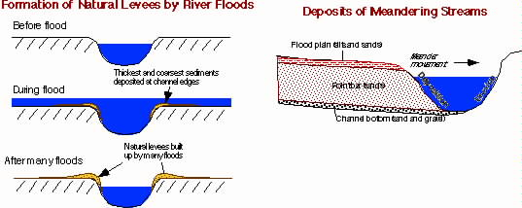

b. Depositional Features of waves (page 220)
Wind generates the waves that lap up the coastline daily.
Low energy waves leave deposits of material
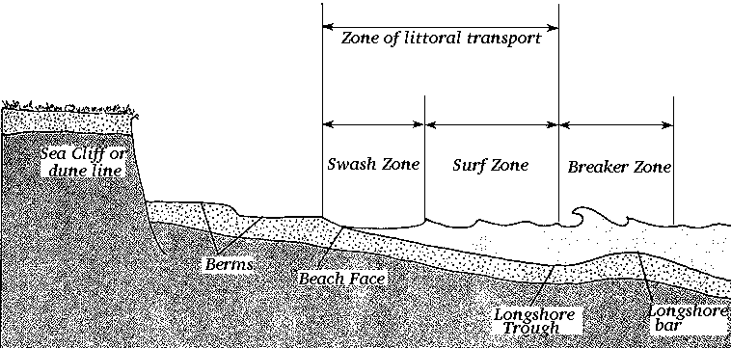
Below is a diagram that shows some of these features
Sea Cliff -- ___________________________________________________
Beach Berm -- ________________________________________________
Long Shore sand Bar-- __________________________________________
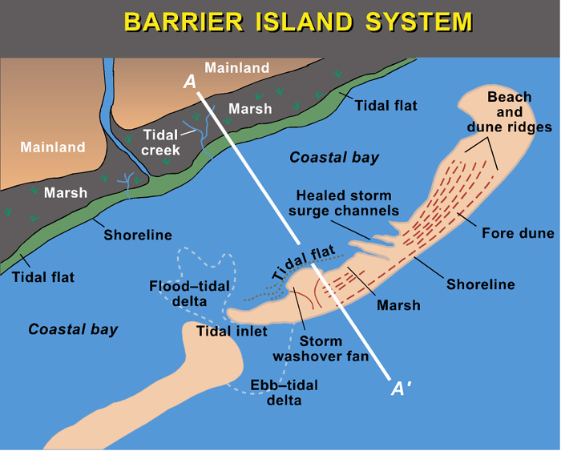
Barrier Island - _______
____________________
____________________

Lagoon - ____________
____________________
____________________

Beach Dunes-- __________________________________________________________________
__________________________________________________________________

Long Shore Drift – (page218) ___________________________________________________________________________________________________________________________

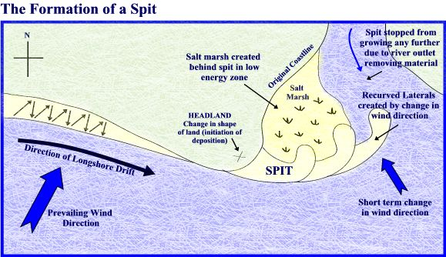
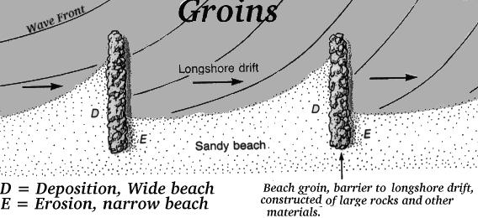

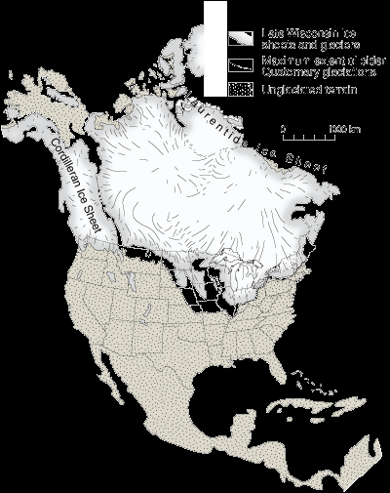
C. Deposition from Ice
The two types of glaciers alpine and continental leave evidence of their presence. Even though none of us were here to see them we know that ice covered much of the area we live.
What are the signs?

1. Ice just lays down the sediment it is unsorted
The sediment from a glacier has a couple of characteristics
- __________________________________

B. ___________________________________

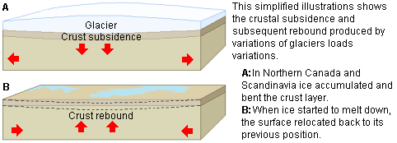
2. Depositional Features from glaciers (page 200)
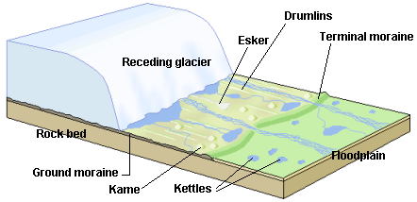

Depositional features of a glacier

Till -- ________________________________
____________________________________________________________________________

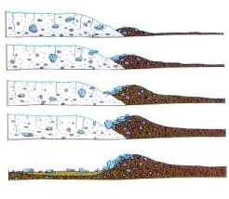
Out-wash plain-- ______________________
______________________________________

Moraine-- _____________________________
______________________________________

Terminal moraine-- ___________________
______________________________________

Recessive moraine— ____________________
_________________________________________

Kettle lake-___________________

Esker - ______________________

Drumlin- ____________________

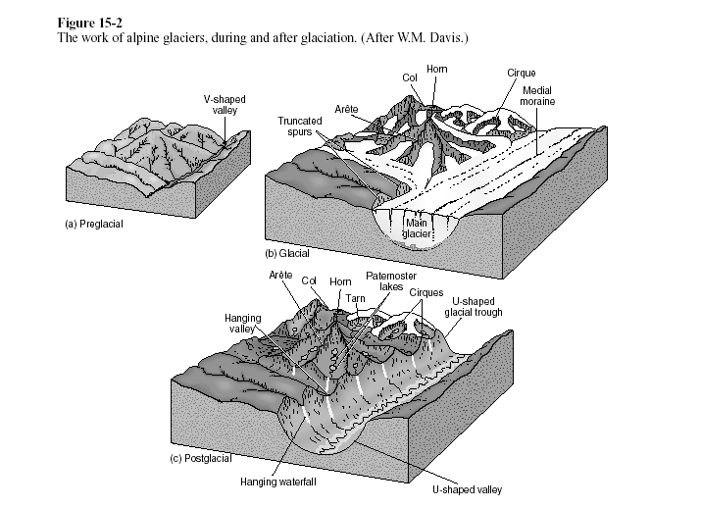
Alpine glaciers leave other evidence of once being present.
Be able to label all of these features on a similar diagram

Hanging wall, cirque, arête, horn, U-shaped valley

D. Deposition from wind (page212)
Deposits
Most of the dust carried by dust storms is in the form of silt-size particles. Deposits of this windblown silt are known as loess. The thickest known deposit of loess, 335 meters, is on the Loess Plateau in China. In Europe and in the Americas, accumulations of loess are generally from 20 to 30 meters thick.

Wind-deposited materials hold clues to past as well as to present wind directions and intensities. These features help us understand the present climate and the forces that molded it. Wind-deposited sand bodies occur as sand sheets, ripples, and dunes.
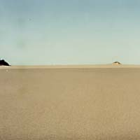
Sand sheets are flat, gently undulating sandy plots of sand surfaced by grains that may be too large for saltation. (The skipping motion of sand particles forced to move by wind) They form approximately 40 percent of Eolian depositional surfaces. The Selima Sand Sheet, which occupies 60,000 square kilometers in southern Egypt and northern Sudan, is one of the Earth's largest sand sheets. The Selima is absolutely flat in some places; in others, active dunes move over its surface.
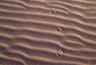
Wind blowing on a sand surface ripples the surface into crests and troughs whose long axes are perpendicular to the wind direction.

(Page 214)
1. Wind-blown sand moves up the gentle upwind side of the dune by saltation (jumping) or creep.
2. Sand accumulates at the brink, the top of the slip face.
3. When the buildup of sand at the brink exceeds the angle of repose; a small avalanche of grains slides down the slip face. Grain by grain, the dune moves downwind, or
1. Sand grains move up the dune's gentle upwind slope by saltation and creep. 2. When particles at the brink of the dune exceed the angle of repose, they spill over in a tiny landslide or avalanche that reforms the slip face.
3. As the avalanching continues, the dune moves in the direction of the wind.
