**Mentor**

**Intern**

**Training Materials**

## **Contents**

**Document Page**

**10 Tips for an Effective Mentoring Relationship 3**

**Benefits to / Responsibilities of Mentors 4**

**Benefits to / Responsibilities of Interns 5**

**Mentor’s Role 6**

**Phases of First Year Teachers’ Attitudes Toward Teaching 7, 8**

**Cognitive Coaching**

**Advice vs Coaching 9**

**Actions of the Cognitive Coach 10**

**Seven Keys to Effective Feedback 11**

**Set Aside Ineffective Listening Patterns 12**

**The Reflecting Conversation Map 13**

**Pausing 14**

**Paraphrasing 15**

**Adult Learning 16, 17**

**Mentoring Action Plan 18**

**Observing 19, 20**

**Increasing Your Mentoring Hours**

**Daily Check-in 21**

**Top Ten Tips for an Effective Mentoring Partnership**

10. Touch base often – face-to-face, texts, emails, phone calls.

Frequency is more important than the length of the meeting.

9. Watch for positives and celebrate them loudly!

8. Limit offering advice to only the most critical situations.

7. Remain confidential – we all need someone to trust.

6. Learn from your mentor. Learn from your intern.

5. Touch base at least twice a week if possible.

Frequent check-ins can seal a partnership.

4. Say what you mean.

3. Ask for what you need.

2. Listen.

1. Touch base daily, if at all possible.

Do you remember a time when you needed a friendly face and the voice of encouragement every day? Me too.

**How Mentoring Benefits a Mentor**

* unique one-on-one professional development
* collaborative learning
* release time with intern
* district trainings and conference opportunities
* satisfaction from coaching a new teacher!

**Responsibilities of a Mentor**

* maintain confidentiality with intern
* provide best practice experiences as well as support/guidance/resources
* communicate frequently
* communicate effectively
* believe in your intern

**How Mentoring Benefits an Intern**

* unique one-on-one professional development
* release time with mentor
* non-evaluative observations
* goal-oriented mentoring
* opportunity to learn from the best!

**Responsibilities of an Intern**

* maintain confidentiality with mentor
* express professional needs to mentor (where you are and where you’d like to be)
* actively participate – relay what helps and what does not
* accept professional feedback
* integrate new ideas
* show eagerness to learn from mentor
* **Definition of a Mentor**
* One who facilitates professional and personal growth in an individual by sharing insights, providing encouragement, and opening doors
* *“Mentor” dates back to ancient Greece when Mentor, a wise teacher and trusted advisor, was asked by his friend Odysseus to watch over his son Telemachus, as he embarked on the lengthy voyage to fight the Trojan war.*



A mentor’s role is: A mentor’s role is NOT:

* to support - to judge
* to inform - to remediate
* to reflect - to correct

**Phases of First Year Teachers’**

**Attitudes Toward Teaching**

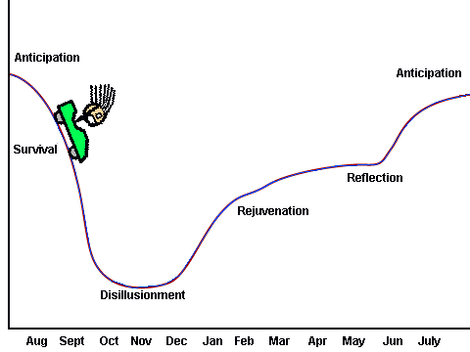

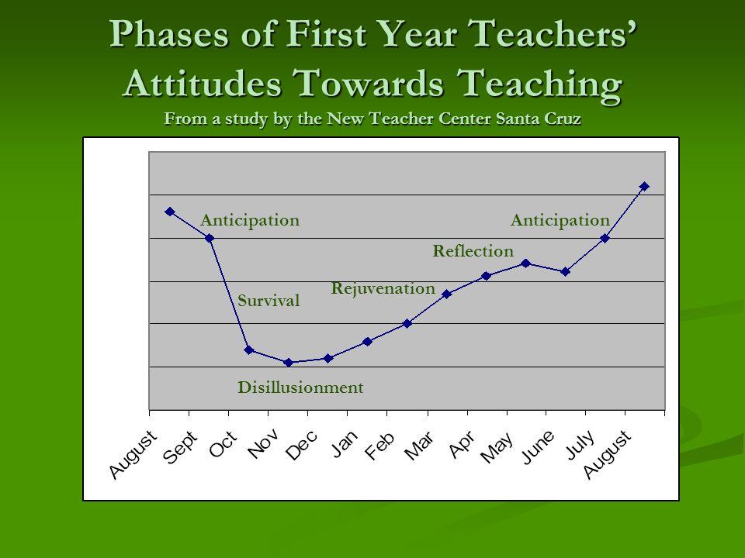

**Advice vs. Coaching**

|  |  |
| --- | --- |
| * Focused on past behavior * Evaluative * “Telling” oriented * Used to help poor   performers move in a  prescribed direction | * Focused on future behavior * Developmental * Inquiry oriented * Used to help good   performers move in a direction  appropriate for them |
|  |  |

**Cognitive Coaching**

a coaching model that

* requires the coach to be **non-judgmental**
* encourages **reflective practice, and**
* guides another personto **self-directed learning.**

**Actions of the Cognitive Coach**

* No value judgments – the intern must judge for him or herself.
* Use **pausing** to make the person think.
* Listen and reflect back what the person said

and clarify a lot - **paraphrasing**.

* Give no advice or recommendations; instead

ask intern to suggest what should be done - **listening**.

**“Seven Keys to Effective Feedback”**

* What is Feedback, Anyway?
* **Feedback Essentials**:

1. Goal-Referenced

2. Tangible and Transparent

3. Actionable

4. User-Friendly

5. Timely

6. Ongoing

7. Consistent

* Progress Toward a Goal & “But There’s No Time!”
* Feedback vs. Advice
* Feedback vs. Evaluation and Grades

**Set Aside Ineffective Listening Patterns**

* **Surface Listening**

Pretending to listen while the listener’s mind is thinking about something else, or when the listener is uninterested in the speaker or the topic.

* **Solution Listening**

Listening with the intention of providing answers, solving the speaker’s problem, or offering advice**.**

* **Autobiographical Listening**

Shifting the focus from the speaker to the listener when the topic being discussed triggers the listener’s own experiences or feelings.

* **Interruptive Listening**

Interrupting the speaker to say what the listener is impatient to say, to shift the conversation to unrelated tangents preferred by the listener, or to sidestep the issue being discussed by the speaker.

* **Inquisitive Listening**

Listening from the perspective of the listener’s self-serving curiosity.

* **Editorial Listening**

Interrupting the speaker to correct or revise the speaker’s words or to finish the speaker’s lines.

* **Agree/Disagree**

**The Reflecting Conversation Map**



Summarize Impressions

Analyze Causal Factors

Construct New Learning

Commit to Application

Reflect on Coaching Process

Cognitive Coaching

**PAUSING**

The concept of wait time, first developed by the noted science educator Mary Budd Rowe, in the late 1960’s, provides insight into the valve of pausing. Dr. Rowe noted the following effects of pauses between 3 and 5 seconds in classrooms:

* Positive changes in affective climate
* Positive changes in the quality of classroom interactions
* an increased level of cognitive functioning
* an increased level of academic achievement
* a decreased number of behavior problems

Dr. Rowe identified three types of wait time. When applied in a coaching conversation, the types of wait time can create the following pauses:

I – after the coach asks a question

II – after the intern responds

III – before the coach responds

Cognitive Coaching

**PRINCIPLES OF PARAPHRASING**

* Attend fully.
* Listen with the intention to understand.
* Capture the *essence* of the message.
* Reflect the *essence* of voice, tone and gestures.
* Make the paraphrase shorter than the original statement.
* Paraphrase before asking a question.
* Use the pronoun “you,” instead of “I.”

**Adult Learning**

*Characteristics of Adult Learners:*

* Control over learning.
* High motivation to learn.
* Pragmatic in learning.
* Learning may be a secondary role.
* **Resistant to change.**
* Adult learners are more diverse.
* Draw on previous experiences in learning.
* Learning is often self-initiated.
* Learning aimed at an immediate goal.

Are self-directed, learn experientally, and approach learning as problem solving.

Bring to the learning environment a wide range of experiences that have become part of their knowledge base and the way they think about things.

Believe that learning must be of value and relevant to their work.

Are goal oriented.

Have different ways of learning

Facilitate mentoring by encouraging interns to build their own knowledge while providing resources and other supports. They support interns in working through problems.

Work with interns, building new information upon the foundation of past experiences and previous knowledge.

Focus on what is important to the intern’s work environment to help the intern improve practice.

Help interns set out goals and learning objectives from the outset. Together mentors and intern assess the progress interns are making toward meeting those goals.

Uses a variety of strategies – observations, journals , dialogue, etc. – in mentoring.

**Adult Learning and Mentoring**

**Adult Learners:** **Mentors:**

Mentoring Action Plan

Date________

|  |  |
| --- | --- |
| What is working | Current focus, challenge or concerns…. |
|  |  |
| Intern’s next steps | Mentor’s next steps… |
|  |  |

|  |
| --- |
| Resources needed Proposed Observation |
|  |

**Observing**

**Plan**

**Observe**

**Discuss**

**Reflect**

**Apply**

**Observation Planning Page**

**Plan**

Lesson Date, Time and Location:

What is the goal of the lesson?

What is the goal of the observation?

Circle focus of data collection: * questioning (wait time) * questioning (types)

* questioning (who) * on-task behaviors * SLANT * student engagement

* other_________________________________

**Observe**

Data collected:

Other strengths: Areas to build:

(Positive feedback) (Corrective feedback)

**Discuss/Provide Feedback**

Schedule asap after lesson:

Employ Cognitive Coaching – Pausing, Listening, Paraphrasing

Provide Positive Feedback (see above)

Limit Corrective Feedback (see above)

**Reflect**

Analyze data together

Employ Cognitive Coaching

**Apply**

Where to go next…

**The Daily Check In** 

*Frequent contact is a key to a*

*successful mentoring partnership.*

**Lake Shore MTIP**

* **Consider stopping by daily to check in with your intern or mentor:**

**5-7 minute visit each instructional day**

**= .5 instructional hour each week**

**= 2 instructional hours per month**

* **Consider sending & responding to a check-in email**

**with your intern/mentor:**

**5-7 minute email exchange each instructional day**

**= .5 instructional hour each week**

**= 2 instructional hours per month**

* **Or consider a routine that includes both daily check ins:**

**5-7 minute visit and email each instructional day**

**= 1 instructional hour each week**

**= 4 instructional** **hours per month!**

**On your Mentoring Log, please record the type of contact as DCI and enter once a week.**

**Thank you for your commitment to mentoring in Lake Shore!**