AP Physics Free Response Practice – Work Power Energy

1974B1. A pendulum consisting of a small heavy ball of mass m at the end of a string of length L is released from a horizontal position. When the ball is at point P, the string forms an angle of θ with the horizontal as shown.
(a) In the space below, draw a force diagram showing all of the forces acting on the ball at P. Identify each force clearly.
(b) Determine the speed of the ball at P.
(c) Determine the tension in the string when the ball is at P.
θ

1974B7. A ski lift carries skiers along a 600 meter slope inclined at 30°. To lift a single rider, it is necessary to move 70 kg of mass to the top of the lift. Under maximum load conditions, six riders per minute arrive at the top. If 60 percent of the energy supplied by the motor goes to overcoming friction, what average power must the motor supply?

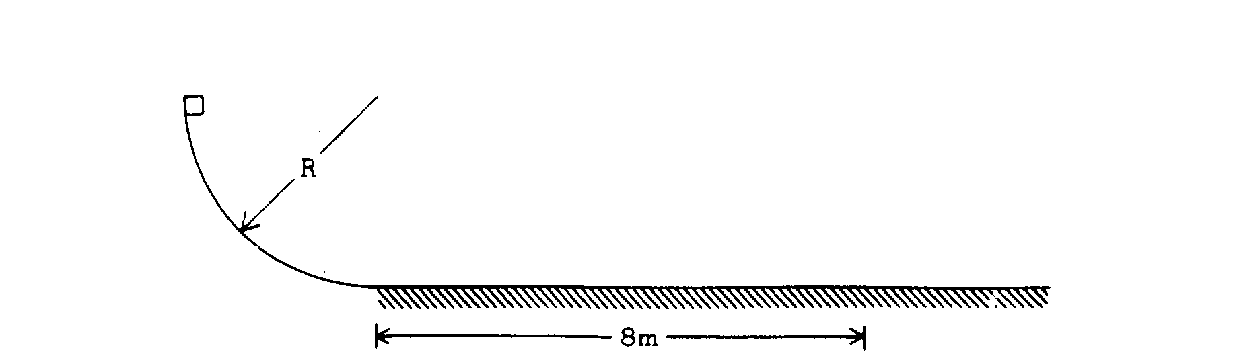

1975B1. A 2-kilogram block is released from rest at the top of a curved incline in the shape of a quarter of a circle of radius R. The block then slides onto a horizontal plane where it finally comes to rest 8 meters from the beginning of the plane. The curved incline is frictionless, but there is an 8-newton force of friction on the block while it slides horizontally. Assume g = 10 meters per second².
a. Determine the magnitude of the acceleration of the block while it slides along the horizontal plane.
b. How much time elapses while the block is sliding horizontally?
c. Calculate the radius of the incline in meters.

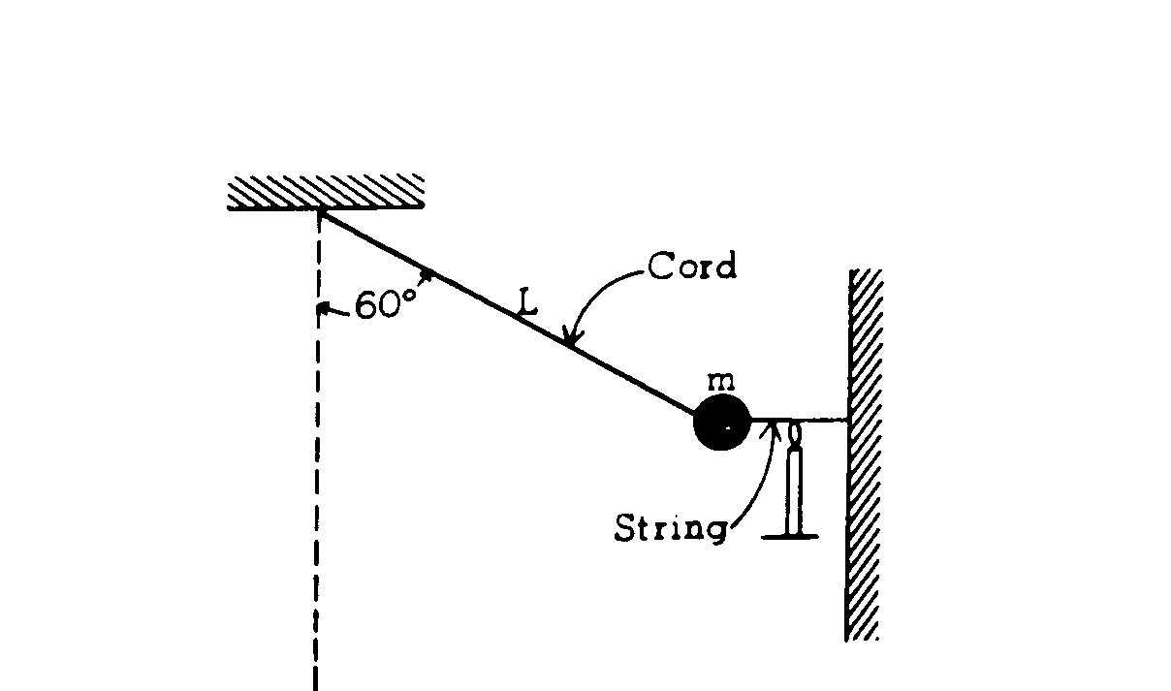
1975B7. A pendulum consists of a small object of mass m fastened to the end of an inextensible cord of length L. Initially, the pendulum is drawn aside through an angle of 60° with the vertical and held by a horizontal string as shown in the diagram above. This string is burned so that the pendulum is released to swing to and fro.
a. In the space below draw a force diagram identifying all of the forces acting on the object while it is held by the string.

b. Determine the tension in the cord before the string is burned.
c. Show that the cord, strong enough to support the object before the string is burned, is also strong enough to support the object as it passes through the bottom of its swing.
1977 B1. A block of mass 4 kilograms, which has an initial speed of 6 meters per second at time t = 0, slides on a horizontal surface.
a. Calculate the work W that must be done on the block to bring it to rest.

If a constant friction force of magnitude 8 newtons is exerted on the block by the surface, determine the following:
b. The speed v of the block as a function of the time t.
c. The distance x that the block slides as it comes to rest

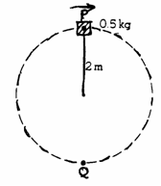
1978B1. A 0.5 kilogram object rotates freely in a vertical circle at the end of a string of length 2 meters as shown above. As the object passes through point P at the top of the circular path, the tension in the string is 20 newtons. Assume g = 10 meters per second squared.

(a) On the following diagram of the object, draw and clearly label all significant forces on the object when it is at the point P.


(b) Calculate the speed of the object at point P.
(c) Calculate the increase in kinetic energy of the object as it moves from point P to point Q.
(d) Calculate the tension in the string as the object passes through point Q.

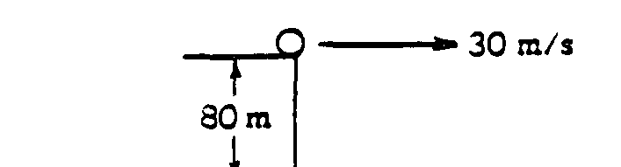

1979B1. From the top of a cliff 80 meters high, a ball of mass 0.4 kilogram is launched horizontally with a velocity of 30 meters per second at time t = 0 as shown above. The potential energy of the ball is zero at the bottom of the cliff. Use g = 10 meters per second squared.

a. Calculate the potential, kinetic, and total energies of the ball at time t = 0.
b. On the axes below, sketch and label graphs of the potential, kinetic, and total energies of the ball as functions of the distance fallen from the top of the cliff

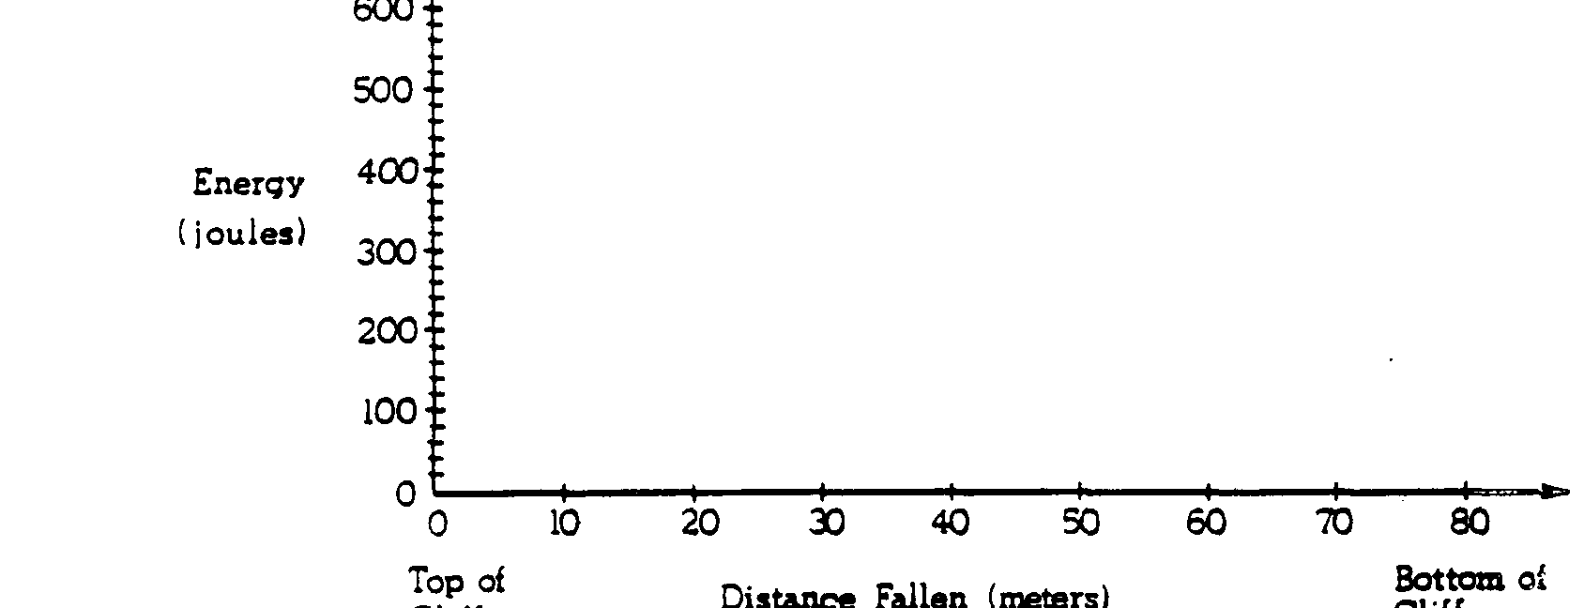
Top of cliff
Bottom of cliff
Distance Fallen (m)

c. On the axes below sketch and label the kinetic and potential energies of the ball as functions of time until the ball hits
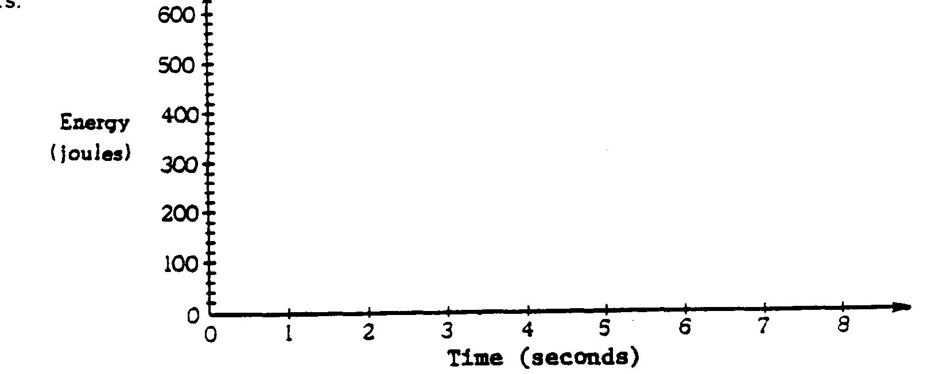

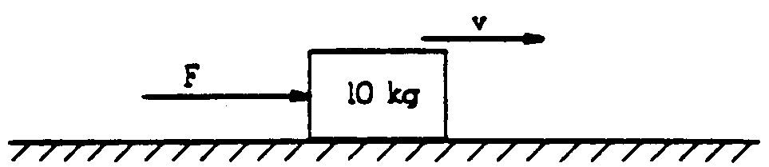
1981B1. A 10-kilogram block is pushed along a rough horizontal surface by a constant horizontal force F as shown above. At time t = 0, the velocity v of the block is 6.0 meters per second in the same direction as the force. The coefficient of sliding friction is 0.2. Assume g = 10 meters per second squared.
a. Calculate the force F necessary to keep the velocity constant.

The force is now changed to a larger constant value F'. The block accelerates so that its kinetic energy increases by 60 joules while it slides a distance of 4.0 meters.
b. Calculate the force F'.
c. Calculate the acceleration of the block.



1981B2. A massless spring is between a 1-kilogram mass and a 3-kilogram mass as shown above, but is not attached to either mass. Both masses are on a horizontal frictionless table. In an experiment, the 1-kilogram mass is held in place and the spring is compressed by pushing on the 3-kilogram mass. The 3-kilogram mass is then released and moves off with a speed of 10 meters per second. Determine the minimum work needed to compress the spring in this experiment.

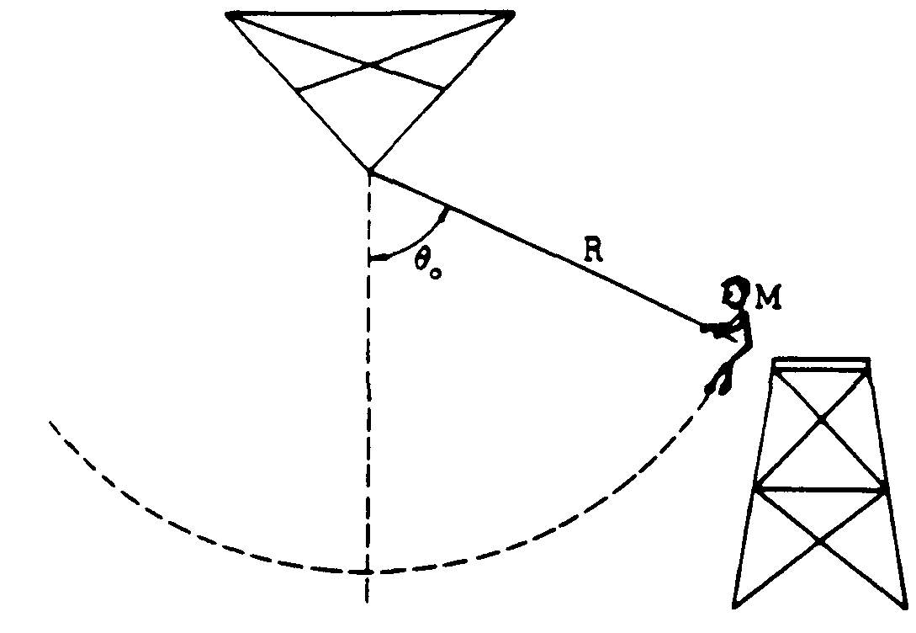

1982B3. A child of mass M holds onto a rope and steps off a platform. Assume that the initial speed of the child is zero. The rope has length R and negligible mass. The initial angle of the rope with the vertical is θ_{o}, as shown in the drawing above.
a. Using the principle of conservation of energy, develop an expression for the speed of the child at the lowest point in the swing in terms of g, R, and cos θ_{o}
b. The tension in the rope at the lowest point is 1.5 times the weight of the child. Determine the value of cos θ_{o}.

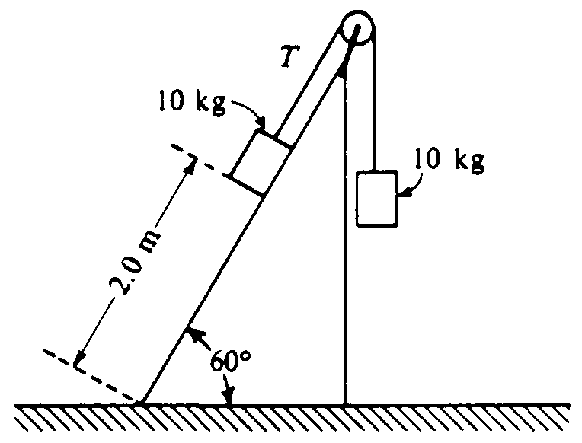

1985B2. Two 10-kilogram boxes are connected by a massless string that passes over a massless frictionless pulley as shown above. The boxes remain at rest, with the one on the right hanging vertically and the one on the left 2.0 meters from the bottom of an inclined plane that makes an angle of 60° with the horizontal. The coefficients of kinetic friction and static friction between the left-hand box and the plane are 0.15 and 0.30, respectively. You may use g = 10 m/s², sin 60° = 0.87, and cos 60° = 0.50.
a. What is the tension T in the string?
b. On the diagram below, draw and label all the forces acting on the box that is on the plane.
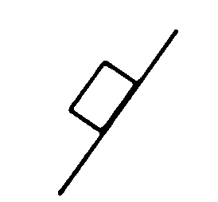

c. Determine the magnitude of the frictional force acting on the box on the plane.

The string is then cut and the left-hand box slides down the inclined plane.
d. Determine the amount of mechanical energy that is converted into thermal energy during the slide to the bottom.
e. Determine the kinetic energy of the left-hand box when it reaches the bottom of the plane.

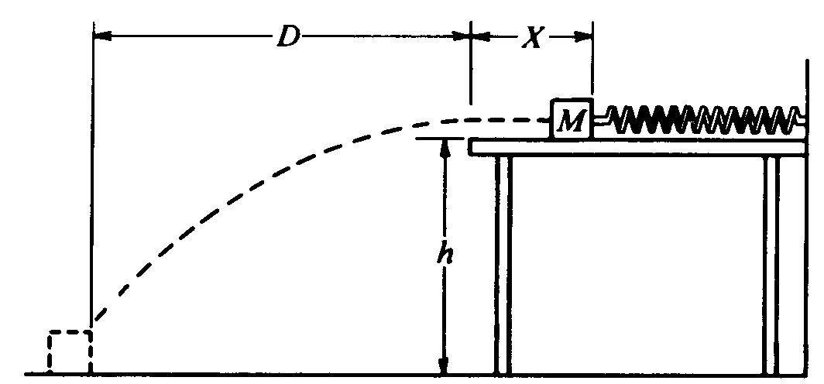

1986B2. One end of a spring is attached to a solid wall while the other end just reaches to the edge of a horizontal, frictionless tabletop, which is a distance h above the floor. A block of mass M is placed against the end of the spring and pushed toward the wall until the spring has been compressed a distance X, as shown above. The block is released, follows the trajectory shown, and strikes the floor a horizontal distance D from the edge of the table. Air resistance is negligible.

Determine expressions for the following quantities in terms of M, X, D, h, and g. Note that these symbols do not include the spring constant.

a. The time elapsed from the instant the block leaves the table to the instant it strikes the floor
b. The horizontal component of the velocity of the block just before it hits the floor
c. The work done on the block by the spring
d. The spring constant

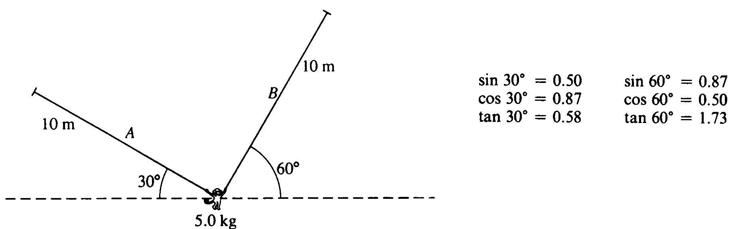

1991B1. A 5.0-kilogram monkey hangs initially at rest from two vines, A and B. as shown above. Each of the vines has length 10 meters and negligible mass.
a. On the figure below, draw and label all of the forces acting on the monkey. (Do not resolve the forces into components, but do indicate their directions.)



b. Determine the tension in vine B while the monkey is at rest.

The monkey releases vine A and swings on vine B. Neglect air resistance.
c. Determine the speed of the monkey as it passes through the lowest point of its first swing.
d. Determine the tension in vine B as the monkey passes through the lowest point of its first swing.

1992B1. A 0.10-kilogram solid rubber ball is attached to the end of an 0.80 meter length of light thread. The ball is swung in a vertical circle, as shown in the diagram above. Point P, the lowest point of the circle, is 0.20 meter above the floor. The speed of the ball at the top of the circle is 6.0 meters per second, and the total energy of the ball is kept constant.
a. Determine the total energy of the ball, using the floor as the zero point for gravitational potential energy.
b. Determine the speed of the ball at point P, the lowest point of the circle.
c. Determine the tension in the thread at
i. the top of the circle;
ii. the bottom of the circle.

The ball only reaches the top of the circle once before the thread breaks when the ball is at the lowest point of the circle.
d. Determine the horizontal distance that the ball travels before hitting the floor.

1996B2 (15 points) A spring that can be assumed to be ideal hangs from a stand, as shown above.
a. You wish to determine experimentally the spring constant k of the spring.
i. What additional, commonly available equipment would you need?
ii. What measurements would you make?
iii. How would k be determined from these measurements?
b. Suppose that the spring is now used in a spring scale that is limited to a maximum value of 25 N, but you would like to weigh an object of mass M that weighs more than 25 N. You must use commonly available equipment and the spring scale to determine the weight of the object without breaking the scale.
i. Draw a clear diagram that shows one way that the equipment you choose could be used with the spring scale to determine the weight of the object,
ii. Explain how you would make the determination.

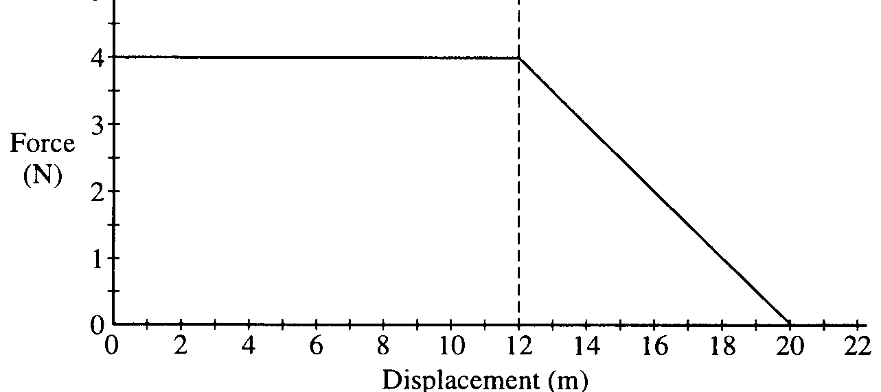

1997B1. A 0.20 kg object moves along a straight line. The net force acting on the object varies with the object's displacement as shown in the graph above. The object starts from rest at displacement x = 0 and time t = 0 and is displaced a distance of 20 m. Determine each of the following.
a. The acceleration of the particle when its displacement x is 6 m.
b. The time taken for the object to be displaced the first 12 m.
c. The amount of work done by the net force in displacing the object the first 12 m.
d. The speed of the object at displacement x = 12 m.
e. The final speed of the object at displacement x = 20 m.

1999B1. The Sojourner rover vehicle shown in the sketch above was used to explore the surface of Mars as part of the Pathfinder mission in 1997. Use the data in the tables below to answer the questions that follow.
Mars Data Sojourner Data
Radius: 0.53 x Earth's radius Mass of Sojourner vehicle: 11.5 kg
Mass: 0.11 x Earth's mass Wheel diameter: 0.13 m
Stored energy available: 5.4 x 10⁵ J
Power required for driving
under average conditions: 10 W
Land speed: 6.7 x 10⁻³ m/s

a. Determine the acceleration due to gravity at the surface of Mars in terms of g, the acceleration due to gravity at the surface of Earth.
b. Calculate Sojourner's weight on the surface of Mars.
c. Assume that when leaving the Pathfinder spacecraft Sojourner rolls down a ramp inclined at 20° to the horizontal. The ramp must be lightweight but strong enough to support Sojourner. Calculate the minimum normal force that must be supplied by the ramp.
d. What is the net force on Sojourner as it travels across the Martian surface at constant velocity? Justify your answer.
e. Determine the maximum distance that Sojourner can travel on a horizontal Martian surface using its stored energy.
f. Suppose that 0.010% of the power for driving is expended against atmospheric drag as Sojourner travels on the Martian surface. Calculate the magnitude of the drag force.

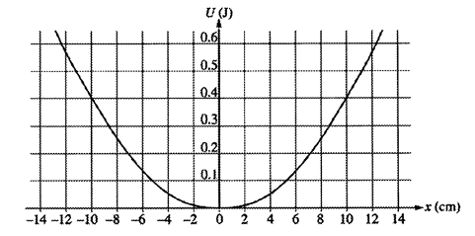
2002B2. A 3.0 kg object subject to a restoring force F is undergoing simple harmonic motion with a small amplitude. The potential energy U of the object as a function of distance x from its equilibrium position is shown above. This particular object has a total energy E: of 0.4 J.

(a) What is the object's potential energy when its displacement is +4 cm from its equilibrium position?

(b) What is the farthest the object moves along the x axis in the positive direction? Explain your reasoning.

(c) Determine the object's kinetic energy when its displacement is – 7 cm.

(d) What is the object's speed at x = 0 ?
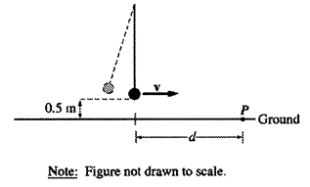

(e) Suppose the object undergoes this motion because it is the bob of a simple pendulum as shown above. If the object breaks loose from the string at the instant the pendulum reaches its lowest point and hits the ground at point P shown, what is the horizontal distance d that it travels?
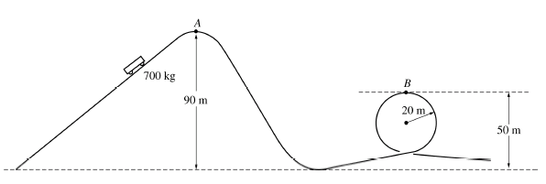

2004B1.
A roller coaster ride at an amusement park lifts a car of mass 700 kg to point A at a height of 90 m above the lowest point on the track, as shown above. The car starts from rest at point A, rolls with negligible friction down the incline and follows the track around a loop of radius 20 m. Point B, the highest point on the loop, is at a height of 50 m above the lowest point on the track.

(a)
i. Indicate on the figure the point P at which the maximum speed of the car is attained.
ii. Calculate the value v_{msx} of this maximum speed.

(b) Calculate the speed v_{B} of the car at point B.

(c)
i. On the figure of the car below, draw and label vectors to represent the forces acting on the car when it is upside down at point B.

ii. Calculate the magnitude of all the forces identified in (c)

(d) Now suppose that friction is not negligible. How could the loop be modified to maintain the same speed at the top of the loop as found in (b)? Justify your answer.

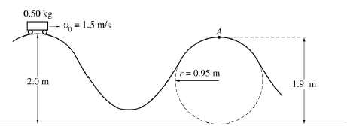

B2004B1.
A designer is working on a new roller coaster, and she begins by making a scale model. On this model, a car of total mass 0.50 kg moves with negligible friction along the track shown in the figure above. The car is given an initial speed v_{o} = 1.5 m/s at the top of the first hill of height 2.0 m. Point A is located at a height of 1.9 m at the top of the second hill, the upper part of which is a circular arc of radius 0.95 m.

(a) Calculate the speed of the car at point A.

(b) On the figure of the car below, draw and label vectors to represent the forces on the car at point A.

(c) Calculate the magnitude of the force of the track on the car at point A.

(d) In order to stop the car at point A, some friction must be introduced. Calculate the work that must be done by the friction force in order to stop the car at point A.

(e) Explain how to modify the track design to cause the car to lose contact with the track at point A before descending down the track. Justify your answer.
B2005B2

A simple pendulum consists of a bob of mass 0.085 kg attached to a string of length 1.5 m. The pendulum is
raised to point Q, which is 0.08 m above its lowest position, and released so that it oscillates with small
amplitude θ between the points P and Q as shown below.

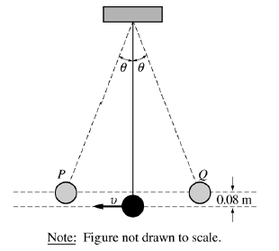

(a) On the figures below, draw free-body diagrams showing and labeling the forces acting on the bob in each of
the situations described.

i. When it is at point P ii. When it is in motion at its lowest position

(b) Calculate the speed v of the bob at its lowest position.
(c) Calculate the tension in the string when the bob is passing through its lowest position.
2005B2.

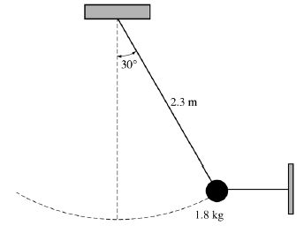

2. (10 points)
A simple pendulum consists of a bob of mass 1.8 kg attached to a string of length 2.3 m. The pendulum is held at an angle of 30° from the vertical by a light horizontal string attached to a wall, as shown above.
(a) On the figure below, draw a free-body diagram showing and labeling the forces on the bob in the position shown above.

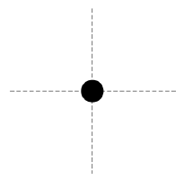

(b) Calculate the tension in the horizontal string.
(c) The horizontal string is now cut close to the bob, and the pendulum swings down. Calculate the speed of the bob at its lowest position.
B2006B2

A small block of mass M is released from rest at the top of the curved frictionless ramp shown above. The block slides down the ramp and is moving with a speed 3.5v_{o} when it collides with a larger block of mass 1.5M at rest at the bottom of the incline. The larger block moves to the right at a speed 2v_{o} immediately after the collision.

Express your answers to the following questions in terms of the given quantities and fundamental constants.
(a) Determine the height h of the ramp from which the small block was released.
(b) The larger block slides a distance D before coming to rest. Determine the value of the coefficient of kinetic friction µ between the larger block and the surface on which it slides.

2006B1

An ideal spring of unstretched length 0.20 m is placed horizontally on a frictionless table as shown above. One end of the spring is fixed and the other end is attached to a block of mass M = 8.0 kg. The 8.0 kg block is also attached to a massless string that passes over a small frictionless pulley. A block of mass m = 4.0 kg hangs from the other end of the string. When this spring-and-blocks system is in equilibrium, the length of the spring is 0.25 m and the 4.0 kg block is 0.70 m above the floor.
(a) On the figures below, draw free-body diagrams showing and labeling the forces on each block when the system is in equilibrium.
M = 8.0 kg m = 4.0 kg

(b) Calculate the tension in the string.
(c) Calculate the force constant of the spring.

The string is now cut at point P.
(d) Calculate the time taken by the 4.0 kg block to hit the floor.
(e) Calculate the maximum speed attained by the 8.0 kg block as it oscillates back and forth
B2008B2

A 4700 kg truck carrying a 900 kg crate is traveling at 25 m/s to the right along a straight, level highway, as
shown above. The truck driver then applies the brakes, and as it slows down, the truck travels 55 m in the next
3.0 s. The crate does not slide on the back of the truck.

(a) Calculate the magnitude of the acceleration of the truck, assuming it is constant.
(b) On the diagram below, draw and label all the forces acting on the crate during braking.

(c)
i. Calculate the minimum coefficient of friction between the crate and truck that prevents the crate from
sliding.

ii. Indicate whether this friction is static or kinetic.
____ Static ____Kinetic

Now assume the bed of the truck is frictionless, but there is a spring of spring constant 9200 N/m attaching the
crate to the truck, as shown below. The truck is initially at rest.

(d) If the truck and crate have the same acceleration, calculate the extension of the spring as the truck
accelerates from rest to 25 m s in 10 s.
(e) At some later time, the truck is moving at a constant speed of 25 m/s and the crate is in equilibrium.
Indicate whether the extension of the spring is greater than, less than, or the same as in part (d) when the
truck was accelerating.
___ Greater ___ Less ___ The same
Explain your reasoning.
2008B2

Block A of mass 2.0 kg and block B of mass 8.0 kg are connected as shown above by a spring of spring constant
80 N/m and negligible mass. The system is being pulled to the right across a horizontal frictionless surface by a
horizontal force of 4.0 N, as shown, with both blocks experiencing equal constant acceleration.
(a) Calculate the force that the spring exerts on the 2.0 kg block.
(b) Calculate the extension of the spring.
The system is now pulled to the left, as shown below, with both blocks again experiencing equal constant
acceleration.

(c) Is the magnitude of the acceleration greater than, less than, or the same as before?
____ Greater ____ Less ____ The same
Justify your answer.
(d) Is the amount the spring has stretched greater than, less than, or the same as before?
____ Greater ____ Less ____ The same
Justify your answer.
(e) In a new situation, the blocks and spring are moving together at a constant speed of 0.50 m s to the left.
Block A then hits and sticks to a wall. Calculate the maximum compression of the spring.
2009B1

In an experiment, students are to calculate the spring constant k of a vertical spring in a small jumping toy
that initially rests on a table. When the spring in the toy is compressed a distance x from its uncompressed
length L₀ and the toy is released, the top of the toy rises to a maximum height h above the point of maximum
compression. The students repeat the experiment several times, measuring h with objects of various masses
taped to the top of the toy so that the combined mass of the toy and added objects is m. The bottom of the toy
and the spring each have negligible mass compared to the top of the toy and the objects taped to it.
(a) Derive an expression for the height h in terms of m, x, k, and fundamental constants.
With the spring compressed a distance x = 0.020 m in each trial, the students obtained the following data for
different values of m.
(b)
i. What quantities should be graphed so that the slope of a best-fit straight line through the data points
can be used to calculate the spring constant k ?
ii. Fill in one or both of the blank columns in the table with calculated values of your quantities,
including units.
(c) On the axes below, plot your data and draw a best-fit straight line. Label the axes and indicate the scale.

(d) Using your best-fit line, calculate the numerical value of the spring constant.
(e) Describe a procedure for measuring the height h in the experiment, given that the toy is only momentarily at
that maximum height.
C1973M2. A 30-gram bullet is fired with a speed of 500 meters per second into a wall.
a. If the deceleration of the bullet is constant and it penetrates 12 centimeters into the wall, calculate the force on the bullet while it is stopping.
b. If the deceleration of the bullet is constant and it penetrates 12 centimeters into the wall, how much time is required for the bullet to stop?

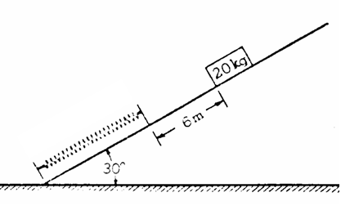

C1982M1. A 20 kg mass, released from rest, slides 6 meters down a frictionless plane inclined at an angle of 30º with the horizontal and strikes a spring of unknown spring constant as shown in the diagram above. Assume that the spring is ideal, that the mass of the spring is negligible, and that mechanical energy is conserved.
a. Determine the speed of the block just before it hits the spring.
b. Determine the spring constant given that the distance the spring compresses along the incline is 3m when the block comes to rest.
c. Is the speed of the block a maximum at the instant the block strikes the spring? Justify your answer.

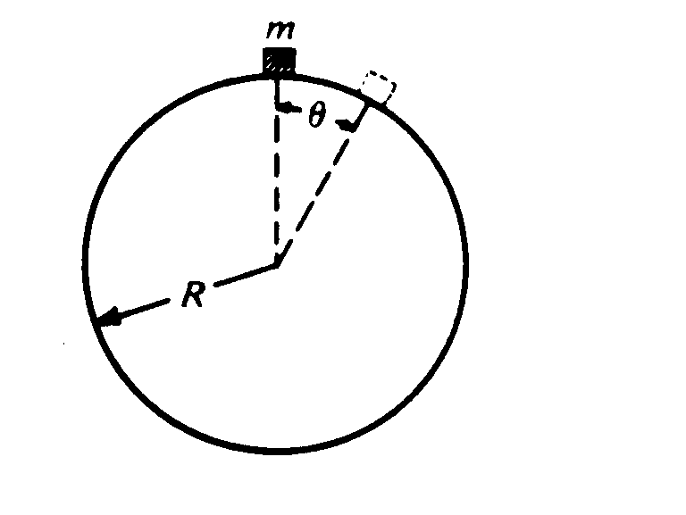
C1983M3. A particle of mass m slides down a fixed, frictionless sphere of radius R. starting from rest at the top.
a. In terms of m, g, R. and θ, determine each of the following for the particle while it is sliding on the sphere.
i. The kinetic energy of the particle
ii. The centripetal acceleration of the mass

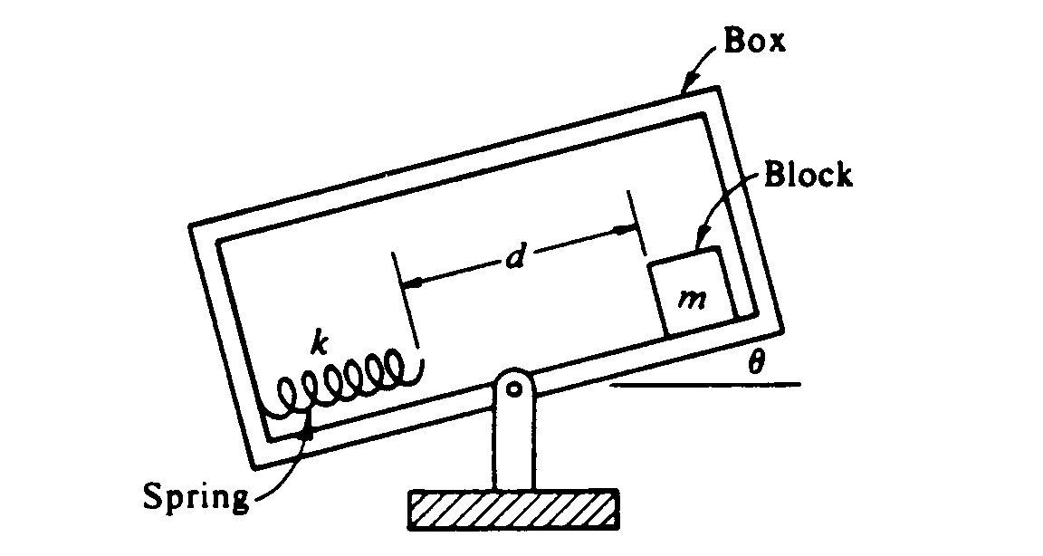
C1985M2. An apparatus to determine coefficients of friction is shown above. At the angle θ shown with the horizontal, the block of mass m just starts to slide. The box then continues to slide a distance d at which point it hits the spring of force constant k, and compresses the spring a distance x before coming to rest. In terms of the given quantities and fundamental constants, derive an expression for each of the following.
a. μ_{s} the coefficient of static friction.
b. ΔE, the loss in total mechanical energy of the block-spring system from the start of the block down the incline to the moment at which it comes to rest on the compressed spring.
c. μ_{k}, the coefficient of kinetic friction.

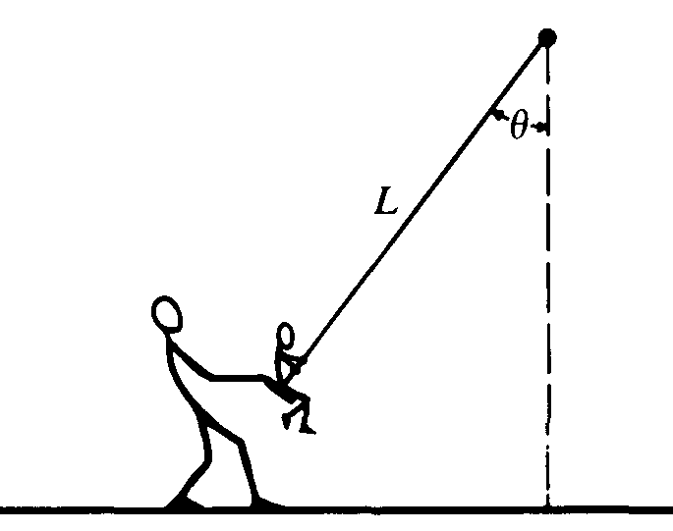
C1987M1. An adult exerts a horizontal force on a swing that is suspended by a rope of length L, holding it at an angle θ with the vertical. The child in the swing has a weight W and dimensions that are negligible compared to L. The weights of the rope and of the seat are negligible. In terms of W and θ, determine
a) The tension in the rope
b) The horizontal force exerted by the adult.
c) The adult releases the swing from rest. In terms of W and θ determine the tension in the rope as the swing passes through its lowest point

C1988M2.

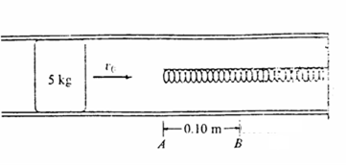

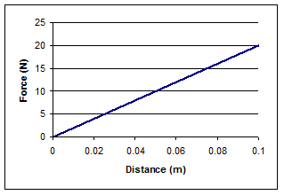
m m

A 5-kilogram object initially slides with speed v_{o} in a hollow frictionless pipe. The end of the pipe contains a spring as shown. The object makes contact with the spring at point A and moves 0.1 meter before coming to rest at point B. The graph shows the magnitude of the force exerted on the object by the spring as a function of the objects distance from point A.
a. Calculate the spring constant for the spring.
b. Calculate the decrease in kinetic energy of the object as it moves from point A to point B.
c. Calculate the initial speed v_{o} of the object

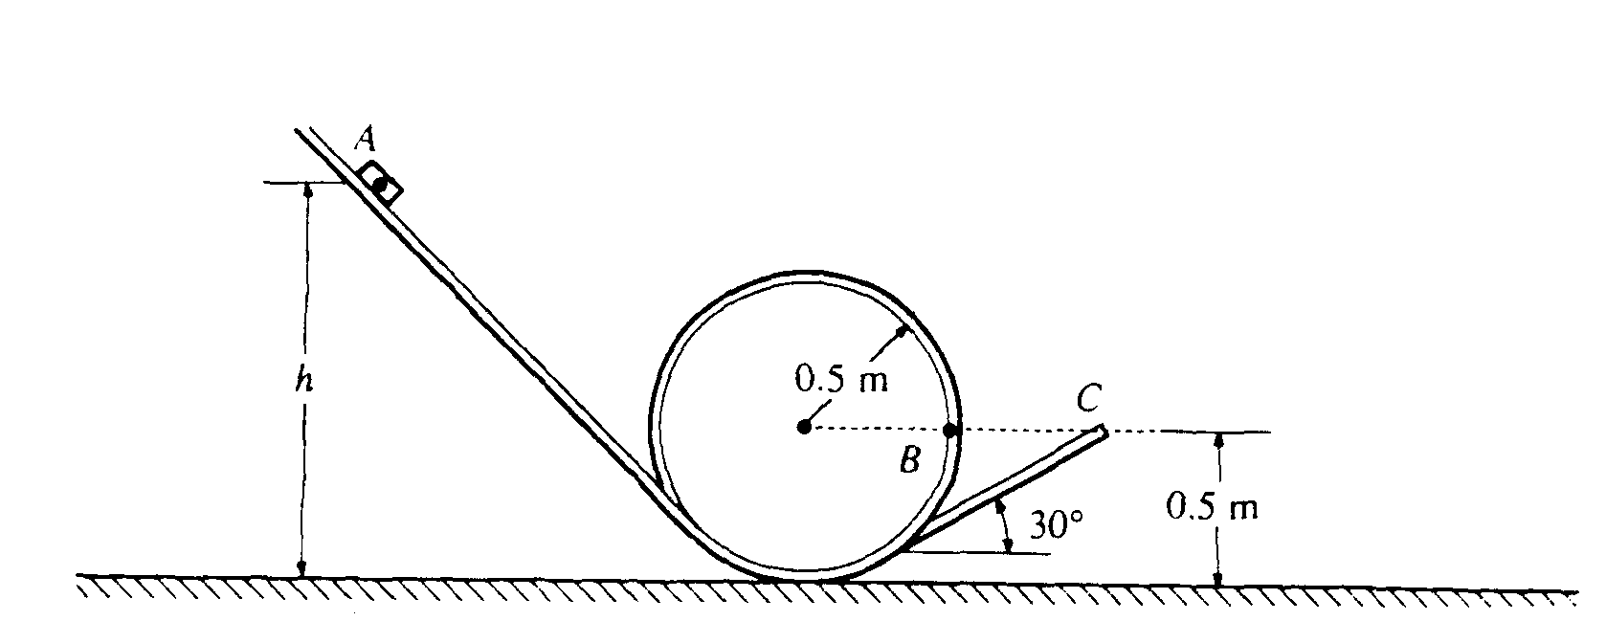

C1989M1. A 0.1 kilogram block is released from rest at point A as shown above, a vertical distance h above the ground. It slides down an inclined track, around a circular loop of radius 0.5 meter, then up another incline that forms an angle of 30° with the horizontal. The block slides off the track with a speed of 4 m/s at point C, which is a height of 0.5 meter above the ground. Assume the entire track to be frictionless and air resistance to be negligible.
a. Determine the height h .
b. On the figure below, draw and label all the forces acting on the block when it is at point B. which is 0.5 meter above the ground.

c. Determine the magnitude of the velocity of the block when it is at point B.
d. Determine the magnitude of the force exerted by the track on the block when it is at point B.
e. Determine the maximum height above the ground attained by the block after it leaves the track.
f. Another track that has the same configuration, but is NOT frictionless, is used. With this track it is found that if the block is to reach point C with a speed of 4 m/s, the height h must be 2 meters. Determine the work done by the frictional force.

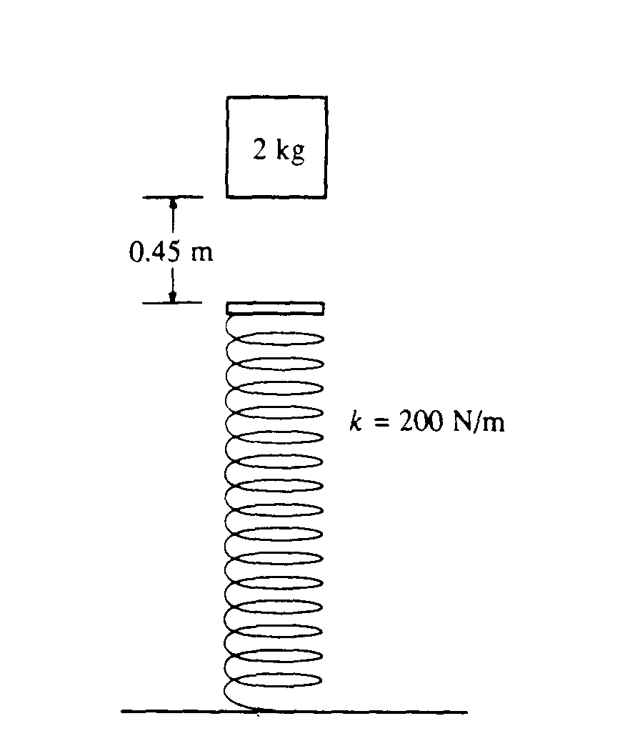
C1989M3. A 2-kilogram block is dropped from a height of 0.45 meter above an uncompressed spring, as shown above. The spring has an elastic constant of 200 newtons per meter and negligible mass. The block strikes the end of the spring and sticks to it.
a. Determine the speed of the block at the instant it hits the end of the spring.
b. Determine the force in the spring when the block reaches the equilibrium position
c. Determine the distance that the spring is compressed at the equilibrium position
d. Determine the speed of the block at the equilibrium position
e. Is the speed of the block a maximum at the equilibrium position, explain.

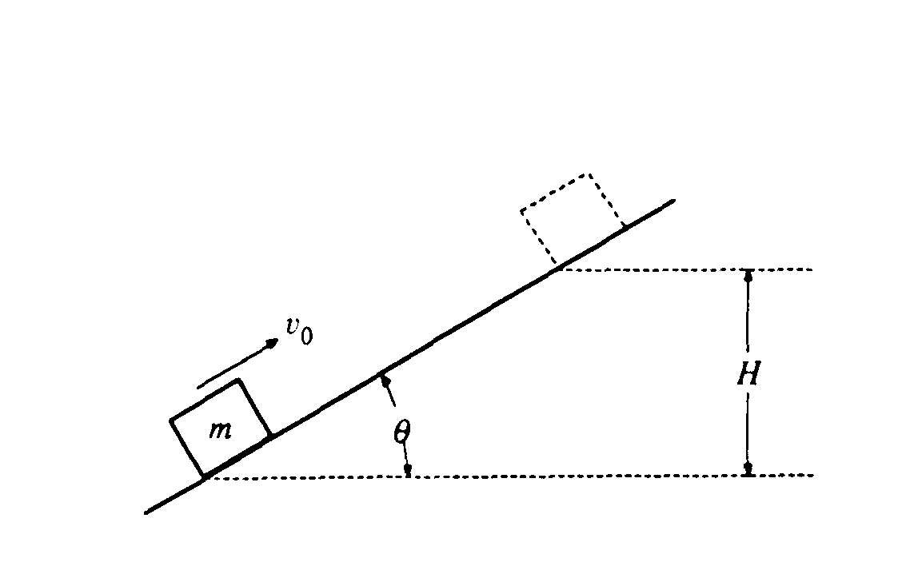
C1990M2. A block of mass m slides up the incline shown above with an initial speed v_{o} in the position shown.
a. If the incline is frictionless, determine the maximum height H to which the block will rise, in terms of the given quantities and appropriate constants.
b. If the incline is rough with coefficient of sliding friction μ, the box slides a distance d = h₂ / sin θ along the length of the ramp as it reaches a new maximum height h₂. Determine the new maximum height h₂ in terms of the given quantities.

C1991M1. A small block of mass 3m moving at speed v₀ / 3 enters the bottom of the circular, vertical loop-the-loop shown above, which has a radius r. The surface contact between the block and the loop is frictionless. Determine each of the following in terms of m, v_{o} , r, and g.
a. The kinetic energy of the block and bullet when they reach point P on the loop
b. The speed v_{min} of the block at the top of the loop to remain in contact with track at all times
c The new required entry speed v_{o}΄ at the bottom of the loop such that the conditions in part b apply.

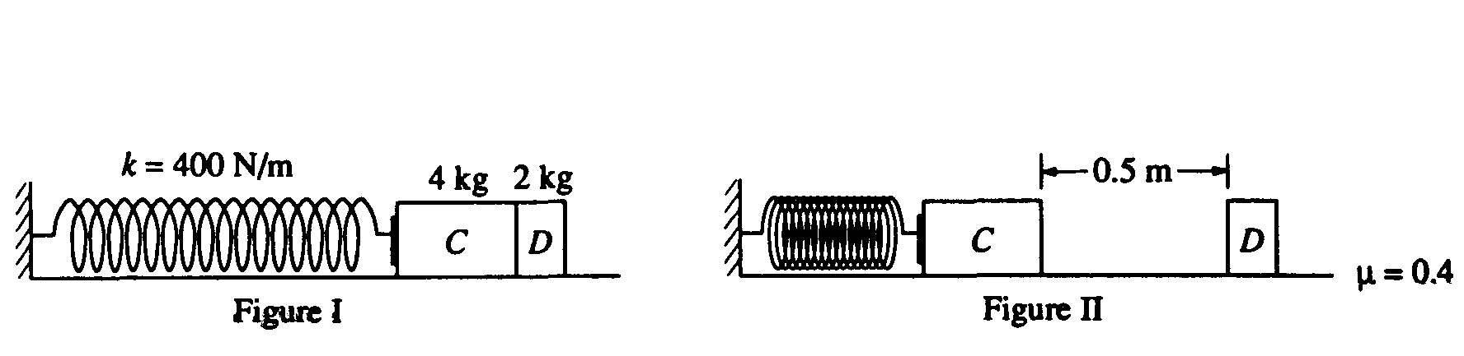
C1993M1. A massless spring with force constant k = 400 newtons per meter is fastened at its left end to a vertical wall, as shown in Figure 1. Initially, block C (mass m_{c} = 4.0 kilograms) and block D (mass m_{D} = 2.0 kilograms) rest on a rough horizontal surface with block C in contact with the spring (but not compressing it) and with block D in contact with block C. Block C is then moved to the left, compressing the spring a distance of 0.50 meter, and held in place while block D remains at rest as shown in Figure 11. (Use g = 10 m/s².)
a. Determine the elastic energy stored in the compressed spring.

Block C is then released and accelerates to the right, toward block D. The surface is rough and the coefficient of friction between each block and the surface is μ = 0.4. The two blocks collide instantaneously, stick together, and move to the right at 3 m/s. Remember that the spring is not attached to block C. Determine each of the following.
b. The speed v_{c} of block C just before it collides with block D
c. The horizontal distance the combined blocks move after leaving the spring before coming to rest

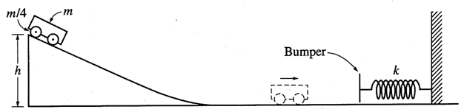

C2002M2. The cart shown above has a mass 2m. The cart is released from rest and slides from the top of an inclined frictionless plane of height h. Express all algebraic answers in terms of the given quantities and fundamental constants.
a. Determine the speed of the cart when it reaches the bottom of the incline.
b. After sliding down the incline and across the frictionless horizontal surface, the cart collides with a bumper of negligible mass attached to an ideal spring, which has a spring constant k. Determine the distance x_{m} the spring is compressed before the cart and bumper come to rest.

C2004M1
A rope of length L is attached to a support at point C. A person of mass m₁ sits on a ledge at position A holding the other end of the rope so that it is horizontal and taut, as shown. The person then drops off the ledge and swings down on the rope toward position B on a lower ledge where an object of mass m₂ is at rest. At position B the person grabs hold of the object and simultaneously lets go of the rope. The person and object then land together in the lake at point D, which is a vertical distance L below position B. Air resistance and the mass of the rope are negligible. Derive expressions for each of the following in terms of m₁, m₂, L, and g.

(a) The speed of the person just before the collision with the object
(b) The tension in the rope just before the collision with the object
(c) After the person hits and grabs the rock, the speed of the combined masses is determined to be v’. In terms of v’ and the given quantities, determine the total horizontal displacement x of the person from position A until the person and object land in the water at point D.
C2007M3.

The apparatus above is used to study conservation of mechanical energy. A spring of force constant 40 N/m is held horizontal over a horizontal air track, with one end attached to the air track. A light string is attached to the other end of the spring and connects it to a glider of mass m. The glider is pulled to stretch the spring an amount x from equilibrium and then released. Before reaching the photogate, the glider attains its maximum speed and the string becomes slack. The photogate measures the time t that it takes the small block on top of the glider to pass through. Information about the distance x and the speed v of the glider as it passes through the photogate are given below.

(a) Assuming no energy is lost, write the equation for conservation of mechanical energy that would apply to this situation.
(b) On the grid below, plot v² versus x² . Label the axes, including units and scale.

(c)
i. Draw a best-fit straight line through the data.
ii. Use the best-fit line to obtain the mass m of the glider.
(d) The track is now tilted at an angle θ as shown below. When the spring is unstretched, the center of the glider is
a height h above the photogate. The experiment is repeated with a variety of values of x.
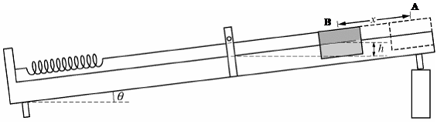

Assuming no energy is lost, write the new equation for conservation of mechanical energy that would
apply to this situation starting from position A and ending at position B

C2008M3

In an experiment to determine the spring constant of an elastic cord of length 0.60 m, a student hangs the cord from a rod as represented above and then attaches a variety of weights to the cord. For each weight, the student allows the weight to hang in equilibrium and then measures the entire length of the cord. The data are recorded in the table below:

(a) Use the data to plot a graph of weight versus length on the axes below. Sketch a best-fit straight line through
the data.

(b) Use the best-fit line you sketched in part (a) to determine an experimental value for the spring constant k of the cord.

The student now attaches an object of unknown mass m to the cord and holds the object adjacent to the point at which the top of the cord is tied to the rod, as shown. When the object is released from rest, it falls 1.5 m before stopping and turning around. Assume that air resistance is negligible.
(c) Calculate the value of the unknown mass m of the object.
(d) i. Determine the magnitude of the force in the cord when the when the mass reaches the equilibrium position.
ii. Determine the amount the cord has stretched when the mass reaches the equilibrium position.
Supplemental

One end of a spring of spring constant k is attached to a wall, and the other end is attached to a block of mass M, as shown above. The block is pulled to the right, stretching the spring from its equilibrium position, and is then held in place by a taut cord, the other end of which is attached to the opposite wall. The spring and the cord have negligible mass, and the tension in the cord is F_{T} . Friction between the block and the surface is negligible. Express all algebraic answers in terms of M, k, F_{T} , and fundamental constants.

(a) On the dot below that represents the block, draw and label a free-body diagram for the block.

(b) Calculate the distance that the spring has been stretched from its equilibrium position.

The cord suddenly breaks so that the block initially moves to the left and then oscillates back and forth.
(c) Calculate the speed of the block when it has moved half the distance from its release point to its equilibrium position.
(d) Suppose instead that friction is not negligible and that the coefficient of kinetic friction between the block and the surface is µ_{k} . After the cord breaks, the block again initially moves to the left. Calculate the initial acceleration of the block just after the cord breaks.

