Heat and Energy Test Review Name ____________________________

Period _____

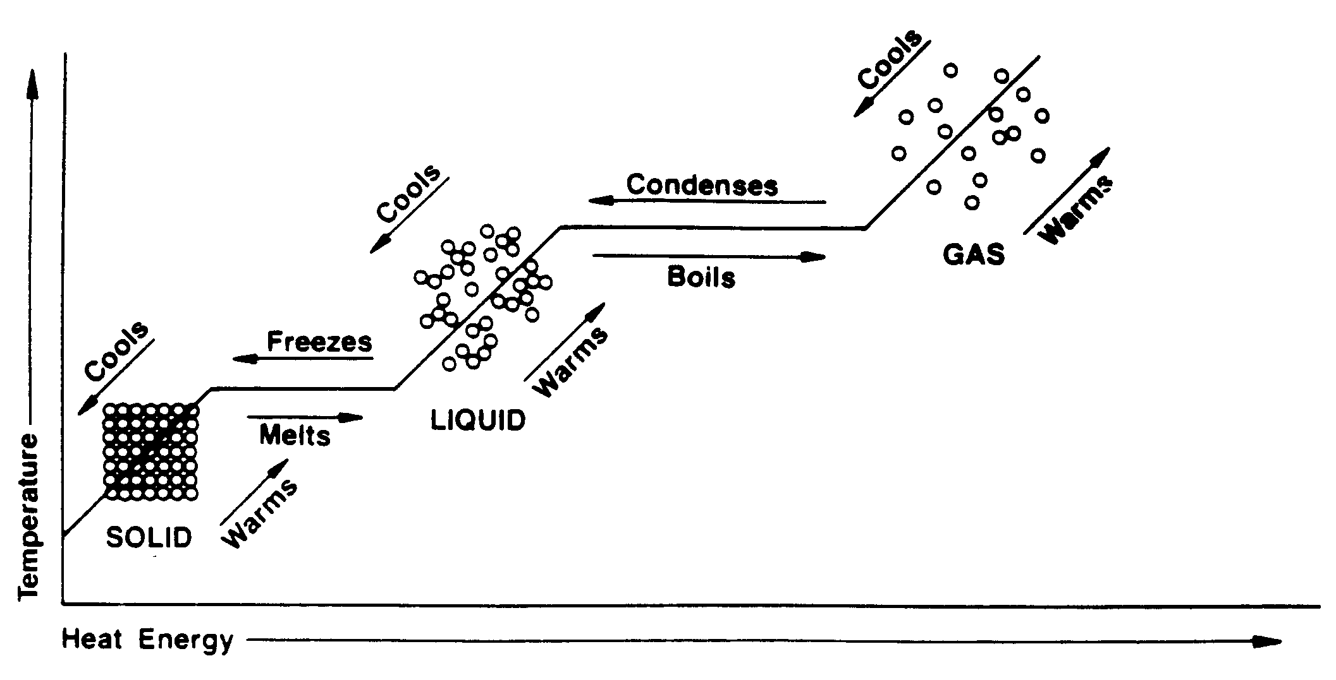

A

B

What is the temperature at point A? _________

What is the temperature at point B? _________

What is happening to the arrangement of particles as the temperature increases?

____________________________________________________________________________________________________________________________

What is happening to the speed of the particles as energy is taken away?

____________________________________________________________________________________________________________________________

Define conductor and give three examples of conductors.

__________________________________________________________________________________________________________________________________________________________________________________________

Define insulator and give three examples of insulators.

__________________________________________________________________________________________________________________________________________________________________________________________

Explain how the lava lamp works; be sure to include the word density.

______________________________________________________________________________________________________________________________________________________________________________________________________________________________________________________________________________________________________________________

What is a solution? Give an example of a solution.

__________________________________________________________________________________________________________________________________________________________________________________________

How can you make a solute dissolve faster in a solvent?

__________________________________________________________________________________________________________________________________________________________________________________________

What is the freezing point of water? __________

What is the boiling point of water? _________

Can solid ice and liquid water exist at the same temperature? Why?

__________________________________________________________________________________________________________________________________________________________________________________________

Define the following terms on a separate piece of lined paper, whenever possible give as many examples as you can.

* matter
* heat
* temperature
* conduction
* convection
* radiation
* thermal energy
* expand
* contract