AP Physics Multiple Choice Practice – Dynamics

SECTION A – Linear Dynamics

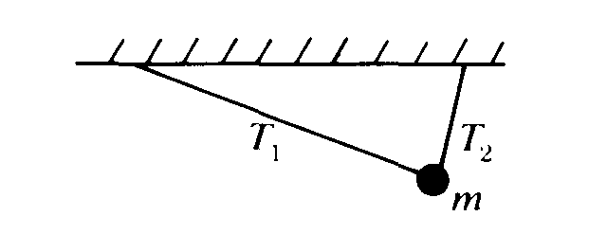

1. A ball of mass m is suspended from two strings of unequal length as shown above. The magnitudes of the tensions T1 and T2 in the strings must satisfy which of the following relations?

(A) Tl = T2 (B) T1 > T2 (C) T1 < T2 (D) Tl + T2 = mg (E) T1 – T2 = mg

Questions 2 – 3

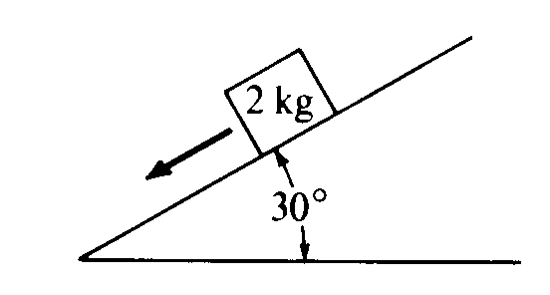

A 2‑kilogram block slides down a 30° incline as shown above with an acceleration of 2 meters per second squared.

2. Which of the following diagrams best represents the gravitational force W. the frictional force f, and the normal force N that act on the block?  
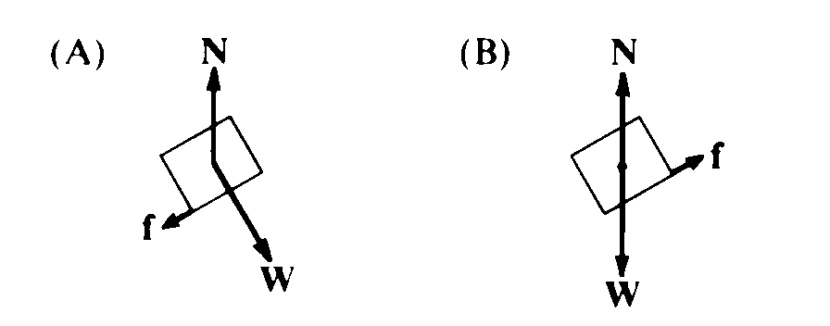 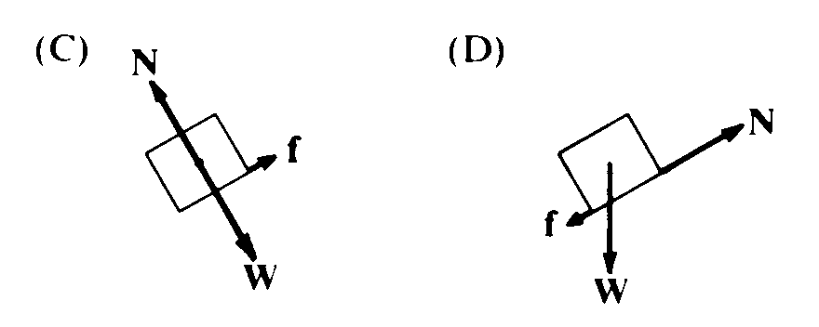 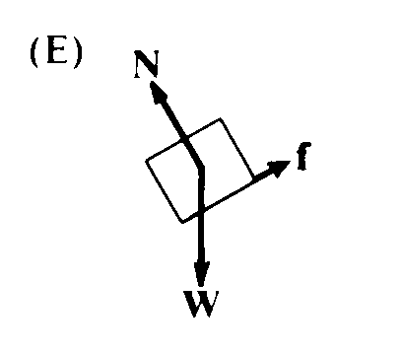

3. The magnitude of the frictional force along the plane is most nearly

(A) 2.5 N (B) 5 N (C) 6 N (D) 10 N (E) 16 N

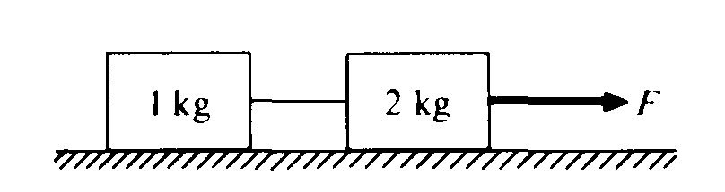

4. When the frictionless system shown above is accelerated by an applied force of magnitude the tension in the string between the blocks is (A) 2F (B) F (C) 2/3 F (D) ½ F (E) 1/3 F

5. A ball falls straight down through the air under the influence of gravity. There is a retarding force F on the ball with magnitude given by F = *bv*, where *v* is the speed of the ball and *b* is a positive constant. The magnitude of the acceleration, a of the ball at any time is equal to which of the following?  
(A) g – b (B) g – bv/m (C) g + bv/m (D) g/b (E) bv/m

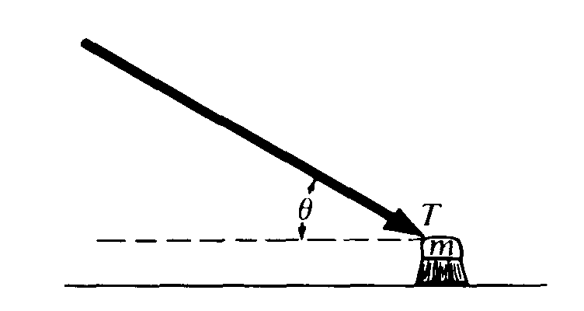

6. A push broom of mass m is pushed across a rough horizontal floor by a force of magnitude T directed at angle θ as shown above. The coefficient of friction between the broom and the floor is μ. The frictional force on the broom has magnitude  
(A) μ(mg + Tsinθ) (B) μ(mg – Tsinθ) (C) μ(mg + Tcosθ) (D) μ(mg – Tcosθ) (E) μmg

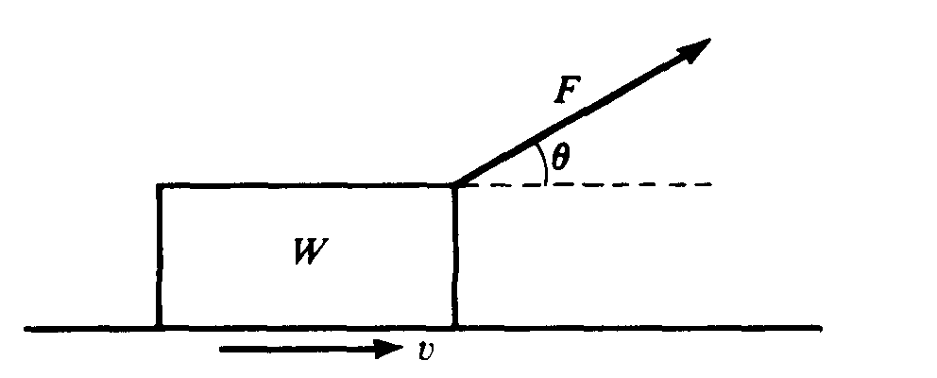

7. A block of weight W is pulled along a horizontal surface at constant speed v by a force F, which acts at an angle of θ with the horizontal, as shown above. The normal force exerted on the block by the surface has magnitude

(A) W – F cos θ (B) W – F sin θ (C) W (D) W + F sin θ (E) W + F cos θ

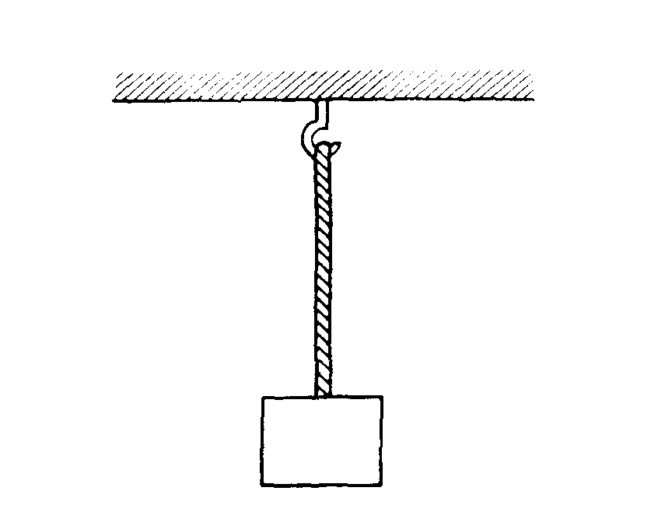

8. A uniform rope of weight 50 newtons hangs from a hook as shown above. A box of weight 100 newtons hangs from the rope. What is the tension in the rope?  
(A) 50 N throughout the rope (B) 75 N throughout the rope (C) 100 N throughout the rope   
(D) 150 N throughout the rope (E) It varies from 100 N at the bottom of the rope to 150 N at the top.

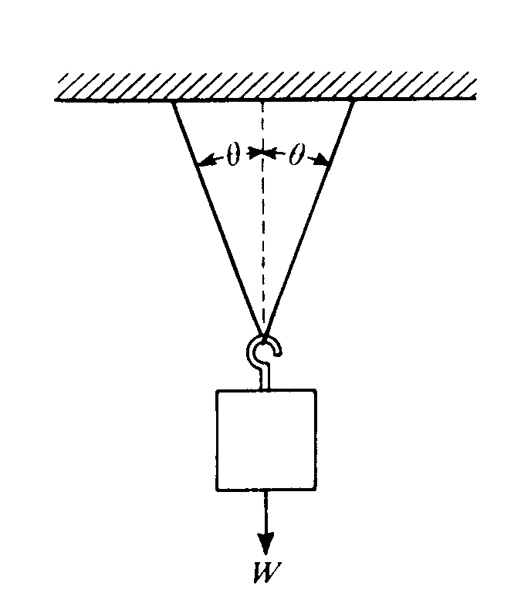

9. When an object of weight W is suspended from the center of a massless string as shown above, the tension at any point in the string is  
(A) 2Wcosθ (B) ½Wcosθ (C) Wcosθ (D) W/(2cosθ) (E) W/(cosθ)

*10. An ideal spring obeys Hooke's law, F = –kx. A mass of 0.50 kilogram hung vertically from this spring stretches the spring 0.075 meter. The value of the force constant for the spring is most nearly

(A) 0.33 N/m (B) 0.66 N/m (C) 6.6 N/m (D) 33 N/m (E) 66 N/m

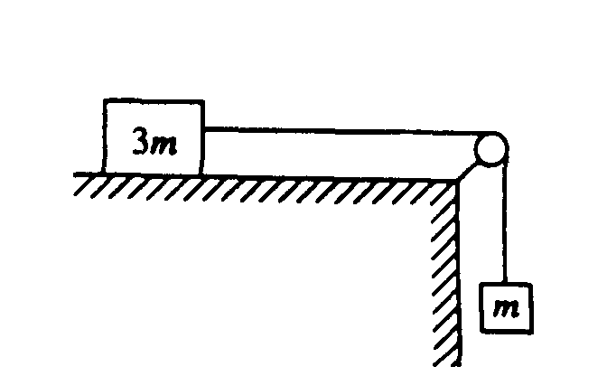

11. A block of mass 3m can move without friction on a horizontal table. This block is attached to another block of mass m by a cord that passes over a frictionless pulley, as shown above. If the masses of the cord and the pulley are negligible, what is the magnitude of the acceleration of the descending block?  
(A) Zero (B) g/4 (C) g/3 (D) 2g/3 (E) g

Questions 12 – 13

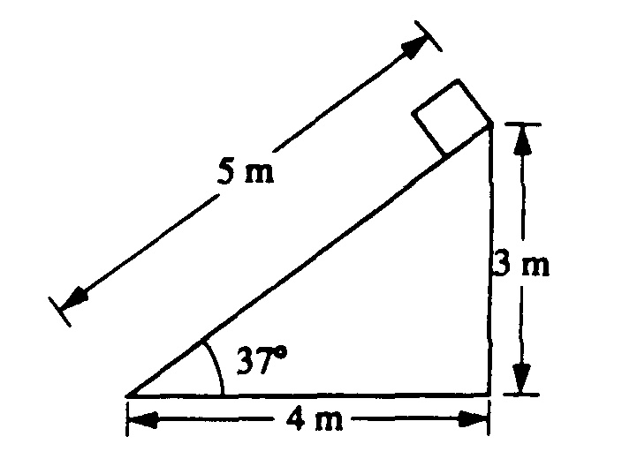

A plane 5 meters in length is inclined at an angle of 37°, as shown above. A block of weight 20 newtons is placed at the top of the plane and allowed to slide down.

12. The mass of the block is most nearly  
(A) 1.0 kg (B) 1.2 kg (C) 1.6 kg (D) 2.0 kg (E) 2.5 kg

13. The magnitude of the normal force exerted on the block by the plane is most nearly  
(A) 10 N (B) 12 N (C) 16 N (D) 20 N (E) 33 N

14. Three forces act on an object. If the object is in translational equilibrium, which of the following must be true?

I. The vector sum of the three forces must equal zero.

II. The magnitudes of the three forces must be equal.

III. All three forces must be parallel.

(A) I only (B) II only (C) I and III only (D) II and III only (E) I, II, and III

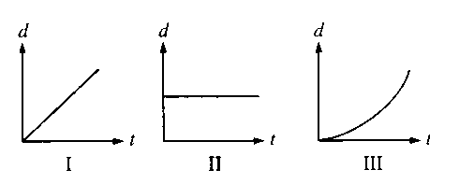

15. Three objects can only move along a straight, level path. The graphs above show the position *d* of each of the objects plotted as a function of time *t*. The sum of the forces on the object is zero in which of the cases?

(A) II only (B) III only (C) I and II only (D) I and III only (E) I, II, and III

*16.For which of the following motions of an object must the acceleration always be zero?

I. Any motion in a straight line

II. Simple harmonic motion

III. Any motion in a circle

(A) I only (B) II only (C) III only (D) Either I or III, but not II   
(E) None of these motions guarantees zero acceleration.

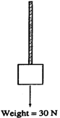

17. A rope of negligible mass supports a block that weighs 30 N, as shown above. The breaking strength of the rope is 50 N. The largest acceleration that can be given to the block by pulling up on it with the rope without breaking the rope is most nearly

(A) 6 m/s2 (B) 6.7 m/s2 (C) 10 m/s2 (D) 15 m/s2 (E) 16.7 m/s2

Questions 18 – 19

A horizontal, uniform board of weight 125 N and length 4 m is supported by vertical chains at each end. A person weighing 500 N is sitting on the board. The tension in the right chain is 250 N.

18. What is the tension in the left chain?

(A) 250 N (B) 375 N (C) 500 N (D) 625 N (E) 875 N

*19. How far from the left end of the board is the person sitting?

(A) 0.4 m (B) 1.5 m (C) 2 m (D) 2.5 m (E) 3 m

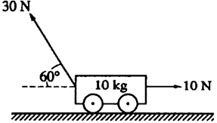

20. The cart of mass 10 kg shown above moves without frictional loss on a level table. A 10 N force pulls on the cart horizontally to the right. At the same time, a 30 N force at an angle of 60° above the horizontal pulls on the cart to the left. What is the magnitude of the horizontal acceleration of the cart?   
(A) 0.5 m/s2 (B) 1.6 m/s2 (C) 2.0 m/s2 (D) 2.5 m/s2 (E) 2.6 m/s2

21. An object of mass *m* is initially at rest and free to move without friction in any direction in the *xy*‑plane. A constant net force of magnitude *F* directed in the *+x* direction acts on the object for 1 s. Immediately thereafter a constant net force of the same magnitude *F* directed in the *+y* direction acts on the object for 1 s. After this, no forces act on the object. Which of the following vectors could represent the velocity of the object at the end of 3 s, assuming the scales on the x and y axes are equal.

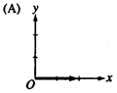 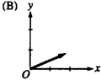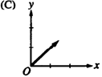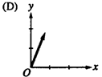 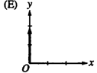

22. Two people are pulling on the ends of a rope. Each person pulls with a force of 100 N. The tension in the rope is:

(A) 0 N (B) 50 N (C) 100 N (D) 141 N (E) 200 N

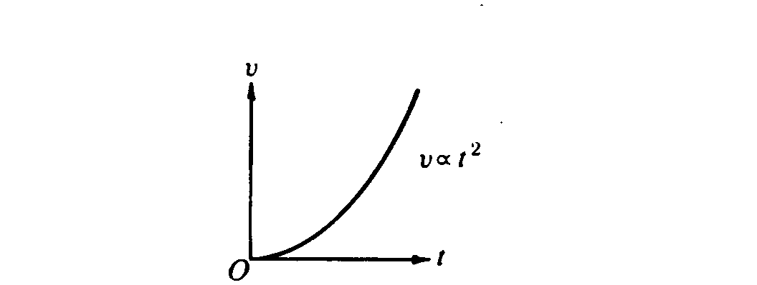

23. The parabola above is a graph of speed v as a function of time t for an object. Which of the following graphs best represents the magnitude F of the net force exerted on the object as a function of time t?



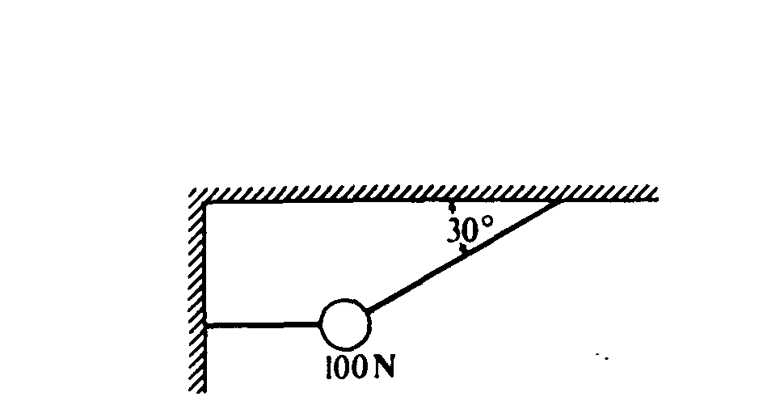

24. A 100‑newton weight is suspended by two cords as shown above. The tension in the slanted cord is

(A) 50 N (B) 100 N (C) 150 N (D) 200 N (E) 250 N

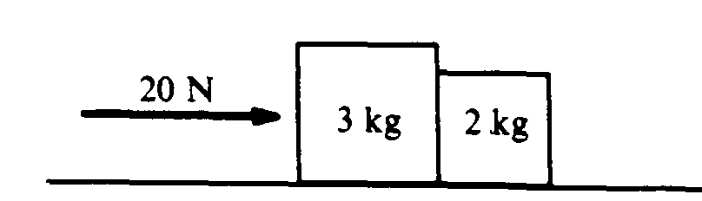

25. Two blocks are pushed along a horizontal friction­less surface by a force of 20 newtons to the right, as shown above. The force that the 2‑kilogram block exerts on the 3‑kilogram block is

(A) 8 newtons to the left (B) 8 newtons to the right (C) 10 newtons to the left   
(D) 12 newtons to the right (E) 20 newtons to the left

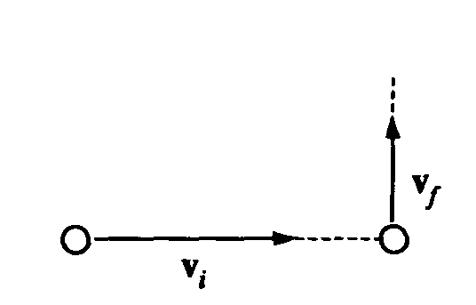

26. A ball initially moves horizontally with velocity vi, as shown above. It is then struck by a stick. After leaving the stick, the ball moves vertically with a velocity vf, which is smaller in magnitude than vi. Which of the following vectors best represents the direction of the average force that the stick exerts on the ball?

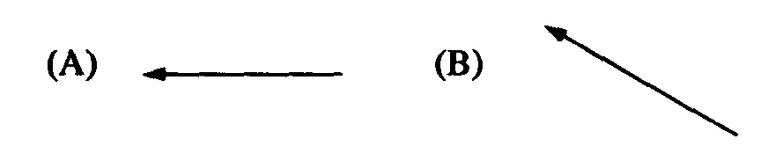 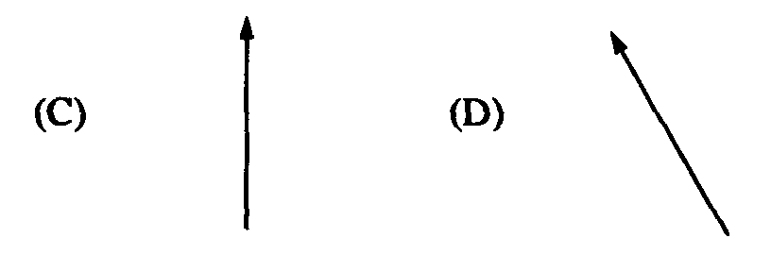 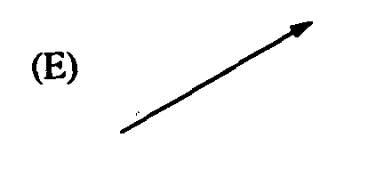

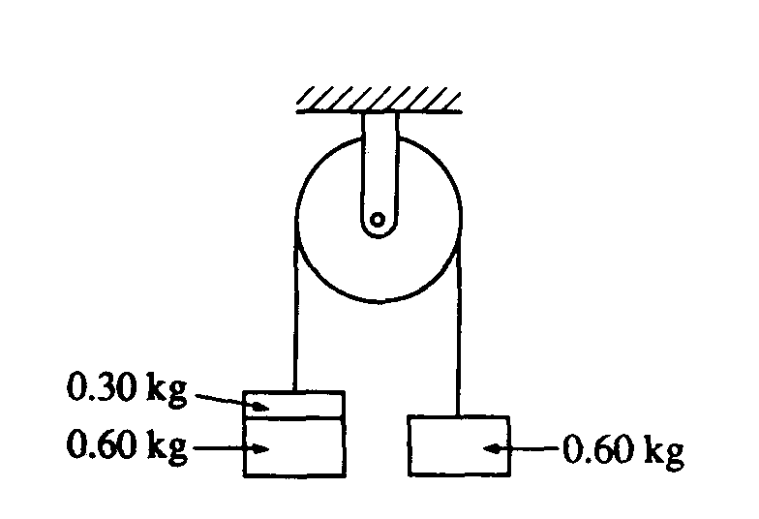

27. Two 0.60‑kilogram objects are connected by a thread that passes over a light, frictionless pulley, as shown above. The objects are initially held at rest. If a third object with a mass of 0.30 kilogram is added on top of one of the 0.60‑kilogram objects as shown and the objects are released, the magnitude of the acceleration of the 0.30‑kilogram object is most nearly

(A) 10.0 m/s2 (B) 6.0 m/s2 (C) 3.0 m/s2 (D) 2.0 m/s2 (E) 1.0 m/s2

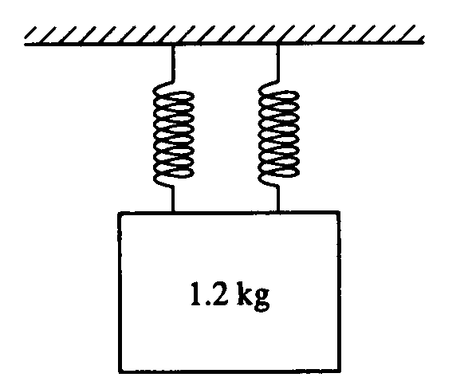

*28. Two identical massless springs are hung from a horizontal support. A block of mass 1.2 kilograms is suspended from the pair of springs, as shown above. When the block is in equilibrium, each spring is stretched an additional 0.15 meter. The force constant of each spring is most nearly

(A) 40 N/m (B) 48 N/m (C) 60 N/m (D) 80 N/m (E) 96 N/m

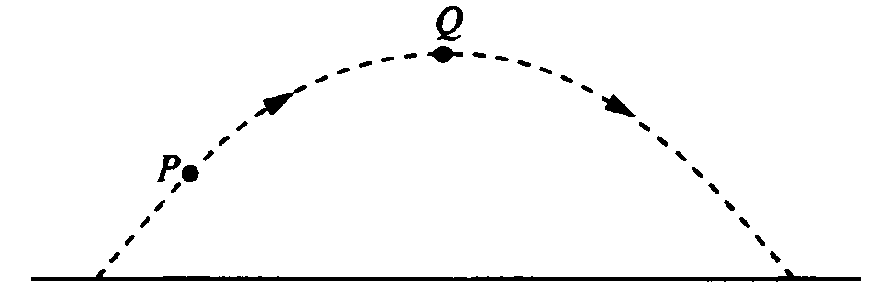

29. A ball is thrown and follows a parabolic path, as shown above. Air friction is negligible. Point Q is the highest point on the path. Which of the following best indicates the direction of the net force on the ball at point P ?

    

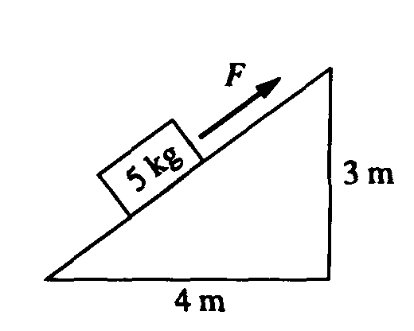

30. A block of mass 5 kilograms lies on an inclined plane, as shown above. The horizontal and vertical supports for the plane have lengths of 4 meters and 3 meters, respectively. The coefficient of friction between the plane and the block is 0.3. The magnitude of the force F necessary to pull the block up the plane with constant speed is most nearly   
(A) 30 N (B) 42 N (C) 49 N (D) 50 N (E) 58 N

Questions 31 – 32

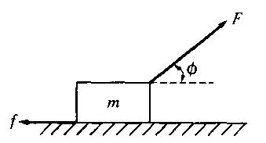

A block of mass m is accelerated across a rough surface by a force of magnitude F that is exerted at an angle φ with the horizontal, as shown above. The frictional force on the block exerted by the surface has magnitude *f*.

31. What is the acceleration of the block?   
(A) F*/m* (B) (Fcosφ)/m (C) (F–*f*)/*m* (D) (Fcosφ–*f*)/*m* (E) (Fsinφ–*mg*)/*m*

32. What is the coefficient of friction between the block and the surface?

(A) *f/mg* (B) *mg*/*f* (C) (*mg*–Fcosφ)/*f* (D) *f*/(*mg–*Fcosφ) (E) *f*/(*mg–*Fsinφ)



33. Three blocks of masses 3*m*, 2*m*, and*s* are connected to strings *A, B*, and *C* as shown above. The blocks are pulled along a rough surface by a force of magnitude *F* exerted by string *C*. The coefficient of friction between each block and the surface is the same. Which string must be the strongest in order not to break?

(A) *A* (B) *B* (C) *C* (D) They must all be the same strength.

(E) It is impossible to determine without knowing the coefficient of friction.

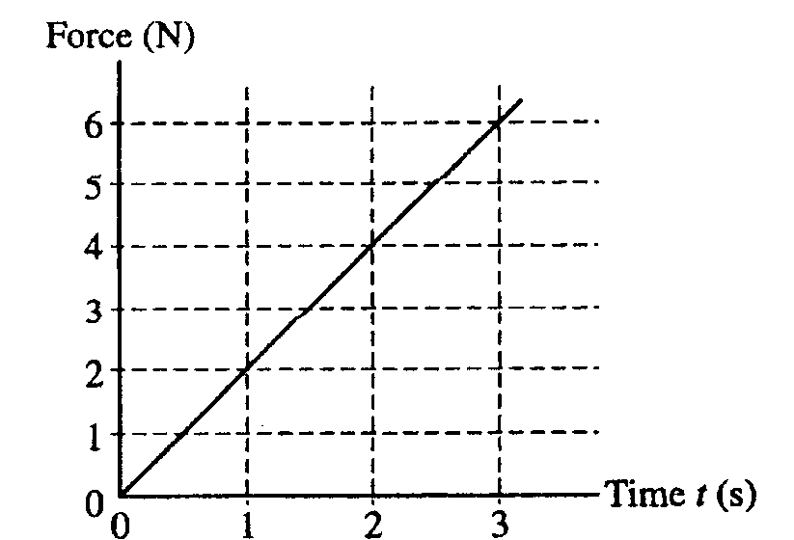

34. A block of mass 3 kg, initially at rest, is pulled along a frictionless, horizontal surface with a force shown as a function of time t by the graph above. The acceleration of the block at t = 2 s is

(A) 3/4 m/s2 (B) 4/3 m/s2 (C) 2 m/s2 (D) 8 m/s2 (E) 12 m/s2

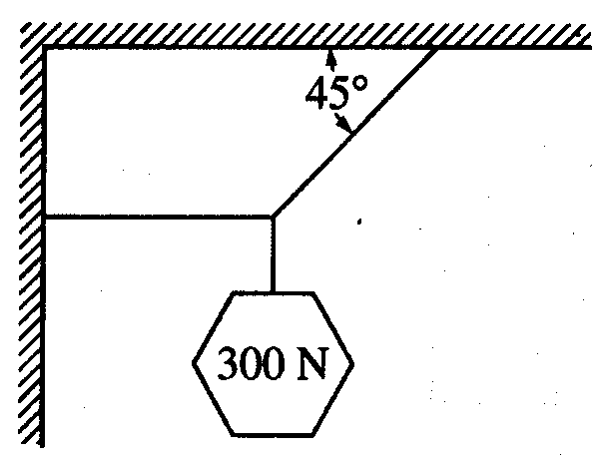

35. An object weighing 300 N is suspended by means of two cords, as shown above. The tension in the horizontal cord is

(A) 0 N (B) 150 N (C) 210 N (D) 300 N (E) 400 N

Questions 36 – 38

A small box is on a ramp tilted at an angle θ above the horizontal. The box may be subject to the following forces: frictional (*f* ) ,gravitational (*mg*), pulling or pushing (*FP*) and normal *(I)*. In the following free‑body diagrams for the box, the lengths of the vectors are proportional to the magnitudes of the forces.

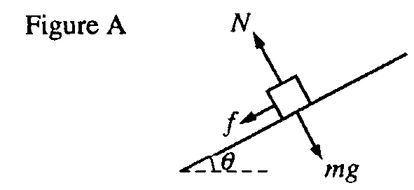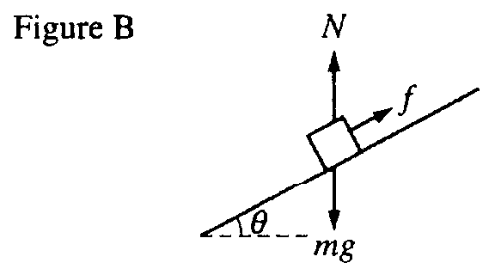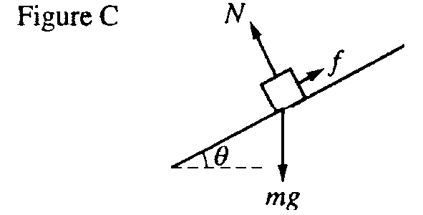

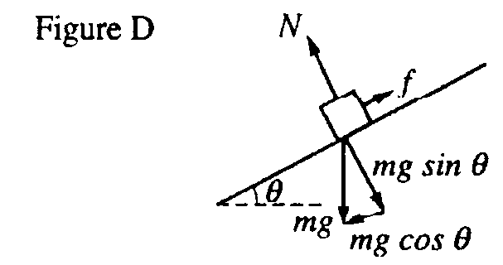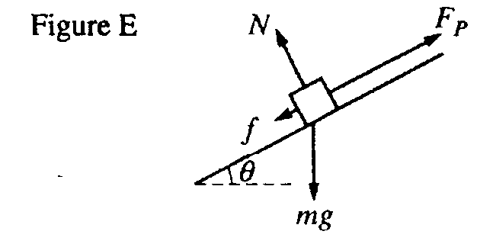

36. Which figure best represents the free‑body diagram for the box if it is accelerating up the ramp?

(A) Figure A (B) Figure B (C) Figure C (D) Figure D (E) Figure E

37. Which figure best represents the free‑body diagram for the box if it is at rest on the ramp?

(A) Figure A (B) Figure B (C) Figure C (D) Figure D (E) Figure E

38. Which figure best represents the free‑body diagram for the box if it is sliding down the ramp at constant speed?

(A) Figure A (B) Figure B (C) Figure C (D) Figure D (E) Figure E

39. Two blocks of masses *M* and *m*, with *M* **>** *m,* are connected by a light string. The string passes over a frictionless pulley of negligible mass so that the blocks hang vertically. The blocks are then released from rest. What is the acceleration of the block of mass *M* ?

(A) g (B)  (C) ** (D) (E) 



40. A horizontal force *F* pushes a block of mass *m* against a vertical wall. The coefficient of friction between the block and the wall is μ. What value of *F* is necessary to keep the block from slipping down the wall?

(A) mg (B) μ mg (C) mg/μ (D) mg(1 ‑ μ) (E) mg(1 + μ)



41. One end of a massless rope is attached to a mass *m*; the other end is attached to a mass of 1.00 kg. The rope is hung over a massless frictionless pulley as shown in the accompanying figure. Mass *m* accelerates downward at 5.0 m/s2. What is *m*?

(A) 3.0 kg (B) 2.0 kg (C) 1.5 kg D. 1.0 kg (E) 0.5 kg



42. As shown in the accompanying figure, a force *F* is exerted at an angle of θ. The block of weight *mg* is initially moving the right with speed *v*. The coefficient of friction between the rough floor and the block is μ. The frictional force acting on the block is:

(A) μ*mg* to the left. (B) μ*mg* to the right. (C) μ*mg* – *F* sin θ to the left. (D) μ(*mg* – *F* cos θ) to the right.

(E) μ(*mg* + *F* sin θ) to the left.

43. The “reaction” force does not cancel the “action” force because:

(A) The action force is greater than the reaction force. (B) The action force is less than the reaction force.

(C) They act on different bodies. (D) They are in the same direction.

(E) The reaction exists only after the action force is removed.



44. A student pulls a wooden box along a rough horizontal floor at constant speed by means of a force *P* as shown to the right. Which of the following must be true?

(A) P > f and N < W.

(B) P > f and N = W.

(C) P = f and N > W.

(D) P = f and N = W.

(E) P < f and N = W.

45. A block with initial velocity 4.0 m/s slides 8.0 m across a rough horizontal floor before coming to rest. The coefficient of friction is:

(A) 0.80 (B) 0.40 (C) 0.20 (D) 0.10 (E) 0.05

46. A car whose mass is 1500 kg is accelerated uniformly from rest to a speed of 20 m/s in 10 s. The magnitude of the net force accelerating the car is:

(A) 1000 N (B) 2000 N (C) 3000 N (D) 20000 N (E) 30000 N

47. An 800-kg elevator accelerates downward at 2.0 m/s2. The force exerted by the cable on the elevator is:

(A) 1.6 kN down (B) 1.6 kN up (C) 6.4 kN up (D) 8.0 kN down (E) 9.6 kN down



48. The 10.0 kg box shown in the figure to the right is sliding to the right along the floor. A horizontal force of 10.0 N is being applied to the right. The coefficient of kinetic friction between the box and the floor is 0.20. The box is moving with:

(A) acceleration to the left. (B) centripetal acceleration. (C) acceleration to the right.

(D) constant speed and constant velocity. (E) constant speed but not constant velocity.



49. Two blocks *X* and *Y* are in contact on a horizontal frictionless surface. A 36 N constant force is applied to *X* as shown to the right. The force exerted by *X* on *Y* is:

(A) 1.5 N (B) 6.0 N (C) 29 N (D) 30 N (E) 36 N

50. Assume the objects in the following diagrams have equal mass and the strings holding them in place are identical. In which case would the string be most likely to break?





51. A string with masses of 1.5 kg and 3.0 kg on its ends is hung over a frictionless, massless pulley as shown to the right. What is the approximate magnitude of the acceleration of the masses?

(A) 1.5 m/s2 (B) 3.0 m/s2 (C) 3.3 m/s2 (D) 6.7 m/s2 (E) 10 m/s2



52. Two blocks of mass 1.0 kg and 3.0 kg are connected by a string which has a tension of 2.0 N. A force *F* acts in the direction shown to the right. Assuming friction is negligible, what is the value of *F*?

(A) 1.0 N (B) 2.0 N (C) 4.0 N (D) 6.0 N (E) 8.0 N

53. An object in equilibrium has three forces, F1 of 30 N, F2 of 50 N, and F3 of 70 N, acting on it. The magnitude of the resultant of F1 and F2 is

(A) 10 N (B) 20 N (C) 40 N (D) 70 N (E) 80 N

54. A 50-kg student stands on a scale in an elevator. At the instant the elevator has a downward acceleration of 1.0 m/s2 and an upward velocity of 3.0 m/s, the scale reads approximately

(A) 350 N (B) 450 N (C) 500 N (D) 550 N (E) 650 N

55. If the net force on an object were doubled while at the same time the mass of the object was halved, then the acceleration of the object is

(A) 1/4 as great. (B) 1/2 as great. (C) 2 times greater. (D) 4 times greater. (E) unchanged



56. A tractor-trailer truck is traveling down the road. The mass of the trailer is 4 times the mass of the tractor. If the tractor accelerates forward, the force that the trailer applies on the tractor is

(A) 4 times greater than the force of the tractor on the trailer.

(B) 2 times greater than the force of the tractor on the trailer.

(C) equal to the force of the tractor on the trailer.

(D) ¼ the force of the tractor on the trailer.

(E) zero since the tractor is pulling the trailer forward.



57. Two boxes are accelerated to the right on a frictionless horizontal surface as shown. The larger box has a mass of 9 kilograms and the smaller box has a mass of 3 kilograms. If a 24 newton horizontal force pulls on the larger box, with what force does the larger box pull on the smaller box?

(A) 3 N (B) 6 N (C) 8 N (D) 18 N (E) 24 N

58. What happens to the inertia of an object when its velocity is doubled?

(A) the object’s inertia becomes 2 times greater

(B) the object’s inertia becomes 2 times greater

(C) the object’s inertia becomes 4 times greater

(D) the object’s inertia becomes 8 times greater

(E) the object’s inertia is unchanged



59. A wooden box is first pulled across a horizontal steel plate as shown in the diagram A. The box is then pulled across the same steel plate while the plate is inclined as shown in diagram B. How does the force required to overcome friction in the inclined case (B) compare to the horizontal case (A)?

(A) the frictional force is the same in both cases

(B) the inclined case has a greater frictional force

(C) the inclined case has less frictional force

(D) the frictional force increases with angle until the angle is 90º, then drops to zero

(E) more information is required

60. An object near the surface of the earth with a weight of 100 newtons is accelerated at 4 m/s2. What is the net force on the object?

(A) 25 N (B) 40 N (C) 250 N (D) 400 N (E) 2500 N

Questions 61 – 62

A car of mass *m* slides across a patch of ice at a speed *v* with its brakes locked. It then hits dry pavement and skids to a stop in a distance *d*. The coefficient of kinetic friction between the tires and the dry road is μ.

61. If the car had a mass of 2*m*, it would have skidded a distance of

(A) 0.5 *d* (B) *d* (C) 1.41 *d* (D) 2 *d* (E) 4 *d*

62. If the car had a speed of 2*v*, it would have skidded a distance of

(A) 0.5 *d* (B) *d* (C) 1.41 *d* (D) 2 *d* (E) 4 *d*

63. A 500-gram ball moving at 15 m/s slows down uniformly until it stops. If the ball travels 15 meters, what was the average net force applied while it was coming to a stop?

(A) 0.37 newtons (B) 3.75 newtons (C) 37.5 newtons (D) 375 newtons (E) 3750 newtons

64. A block rests on a flat plane inclined at an angle of 30º with respect to the horizontal. What is the minimum coefficient of friction necessary to keep the block from sliding?

(A) (B) (C) (D) (E)

65. A force of 6 newtons and a force of 10 newtons can be combine to form a resultant with a magnitude of which of the following

(A) 0 newtons (B) 2 newtons (C) 8 newtons (D) 20 newtons (E) 60 newtons

66. The order of magnitude of the weight of an apple is:

# (A) 10–4 N (B) 10–2 N (C) 10–1 N (D) 100 N (E) 101 N

Questions 67 – 68

A 5 kg block rests on a flat plane inclined at an angle of 30o to the horizon as shown in the diagram below.

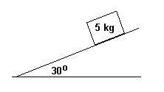

67. What would be the acceleration of the block down the plane assuming the force of friction is negligible?

(A) 0.5 m/s2 (B) 0.87 m/s2 (C) 5 m/s2 (D) 8.7 m/s2 (E) 10 m/s2

68. If the block is placed on a second plane (where friction is significant) inclined at the same angle, it will begin to accelerate at 2.0 m/s2. What is the force of friction between the block and the second inclined plane?

(A) 10 N (B) 15 N (C) 25 N (D) 43.3 N (E) 50 N

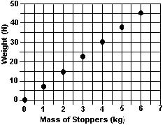

69. The graph at left shows the relationship between the mass of a number of rubber stoppers and their resulting weight on some far-off planet. The slope of the graph is a representation of the:

(A) mass of a stopper

(B) density of a stopper

(C) volume of a stopper

(D) acceleration due to gravity

(E) number of stoppers for each unit of weight

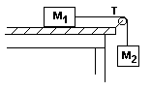

70. Two masses, *m1* and *m2*, are connected by a cord and arranged as shown in the diagram with *m1* sliding along on a frictionless surface and *m2* hanging from a light frictionless pulley. What would be the mass of the falling mass, *m2*, if both the sliding mass, *m1*, and the tension, *T*, in the cord were known?

(A)  (B)  (C)  (D)  (E) 

71. A box with a mass of 50 kg is dragged across the floor by a rope which makes an angle of 30º with the horizontal. Which of the following would be closest to the coefficient of kinetic friction between the box and the floor if a 250 newton force on the rope is required to move the crate at a constant speed of 20 m/s as shown in the diagram?

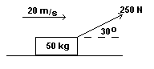

(A) 0.26 (B) 0.33 (C) 0.44 (D) 0.59 (E) 0.77

Questions 72 – 74

A 2 kg mass and a 4 kg mass on a horizontal frictionless surface are connected by a massless string A. They are pulled horizontally across the surface by a second string B with a constant acceleration of 12 m/s2.

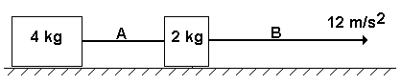

72. What is the magnitude of the force of string B on the 2 kg mass?

(A) 72 N (B) 48 N (C) 24 N (D) 6 N (E) 3 N

73. What is the magnitude of the force of string A on the 4 kg mass?

(A) 72 N (B) 48 N (C) 24 N (D) 6 N (E) 3 N

74. What is the magnitude of the net force on the 2 kg mass?

(A) 72 N (B) 48 N (C) 24 N (D) 6 N (E) 3 N

75. A mass is suspended from the roof of a lift (elevator) by means of a spring balance. The lift (elevator) is moving upwards and the readings of the spring balance are noted as follows:

Speeding up: *RU* Constant speed: *RC* Slowing down: *RD*

Which of the following is a correct relationship between the readings?

(A)  *RU* > *RC*­­ (B) *RU* = *RD* (C) *RC* = *RD* (D) *RC* < *RD* (E) *RU < RD*

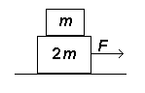

76. A small box of mass *m* is placed on top of a larger box of mass *2m* as shown in the diagram at right. When a force *F* is applied to the large box, both boxes accelerate to the right with the same acceleration. If the coefficient of friction between all surfaces is *μ*, what would be the force accelerating the smaller mass?

(A)  (B)  (C)  (D)  (E) 

77. The S.I. unit of force is named the newton in honor of Sir Isaac Newton's contributions to physics. Which of the following combination of units is the equivalent of a newton?

(A)  (B)  (C)  (D)  (E) 

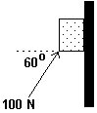78. A 6.0 kg block initially at rest is pushed against a wall by a 100 N force as shown. The coefficient of kinetic friction is 0.30 while the coefficient of static friction is 0.50. What is true of the friction acting on the block after a time of 1 second?

(A) Static friction acts upward on the block.

(B) Kinetic friction acts upward on the block

(C) No friction acts on the block

(D) Kinetic friction acts downward on the block.

(E) Static friction acts downward on the block.

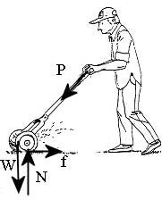79. A homeowner pushes a lawn mower across a horizontal patch of grass with a constant speed by applying a force P. The arrows in the diagram correctly indicate the directions but not necessarily the magnitudes of the various forces on the lawn mower. Which of the following relations among the various force magnitudes, *W, f, N, P* is CORRECT?

(A) *P* > *f* and *N* > *W*

(B) *P* < *f* and *N =* *W*

(C) *P* > *f* and *N* < *W*

(D) *P* = *f* and *N* > *W*

(E) none of the above

*80.A mass, M, is at rest on a frictionless surface, connected to an ideal horizontal spring that is unstretched. A person extends the spring 30 cm from equilibrium and holds it at this location by applying a 10 N force. The spring is brought back to equilibrium and the mass connected to it is now doubled to 2M. If the spring is extended back 30 cm from equilibrium, what is the necessary force applied by the person to hold the mass stationary there?

(A) 20.0 N (B) 14.1 N (C) 10.0 N (D) 7.07 N (E) 5.00 N

1. 81. A baseball is thrown by a pitcher with a speed of 35 m/s. The batter swings and hits the ball. The magnitude of the force that the ball exerts on the bat is always
   1. (A) zero as it is only the bat that exerts a force on the ball.
   2. (B) equal to the gravitational force acting on the ball.
   3. (C) larger than the force the bat exerts on the ball.
   4. (D) smaller than the force the bat exerts on the ball.
   5. (E) equal to the force that the bat exerts on the ball.
2. 
3. 82. A book leans against a crate on a table. Neither is moving. Which of the following statements concerning this situation is CORRECT?
   1. (A) The force of the book on the crate is less than that of crate on the book.
   2. (B) Although there is no friction acting on the crate, there must be friction acting on the book or else it will fall.
   3. (C) The net force acting on the book is zero.
   4. (D) The direction of the frictional force acting on the book is in the same direction as the frictional force acting on the crate.
   5. (E) The Newton’s Third Law reaction force to the weight of the book is the normal force from the table.

83. A crate of toys remains at rest on a sleigh as the sleigh is pulled up a hill with an increasing speed. The crate is not fastened down to the sleigh. What force is responsible for the crate’s increase in speed up the hill?

1. (A) the contact force (normal force) of the ground on the sleigh
   1. (B) the force of static friction of the sleigh on the crate
   2. (C) the contact force (normal force) of the sleigh on the crate
   3. (D) the gravitational force acting on the sleigh
   4. (E) no force is needed

84. A student weighing 500 N stands on a bathroom scale in the school’s elevator. When the scale reads 520 N, the elevator must be

(A) accelerating upward. (B) accelerating downward. (C) moving upward at a constant speed.

(D) moving downward at a constant speed. (E) at rest.

85. In which one of the following situations is the net force constantly zero on the object?

(A) A mass attached to a string and swinging like a pendulum.

(B) A stone falling freely in a gravitational field.

(C) An astronaut floating in the International Space Station.

(D) A snowboarder riding down a steep hill.

(E) A skydiver who has reached terminal velocity.

86. A box slides to the right across a horizontal floor. A person called Ted exerts a force *T* to the right on the box. A person called Mario exerts a force *M* to the left, which is half as large as the force *T*. Given that there is friction *f* and the box accelerates to the right, rank the sizes of these three forces exerted on the box.

(A) *f* < *M* < *T* (B) *M* < *f* < *T* (C) *M* < *T* < *f* (D) *f* = *M* < *T* (E) It cannot be determined.

87. You hold a rubber ball in your hand. The Newton's third law companion force to the force of gravity on the ball is the force exerted by which object onto what other object?

(A) ball on the hand (B) Earth on the ball (C) ball on the Earth (D) Earth on your hand (E) hand on the ball



88. An object on an inclined plane has a gravitational force of magnitude 10 *N* acting on it from the Earth. Which of the following gives the correct components of this gravitational force for the coordinate axes shown in the figure? The y-axis is perpendicular to the incline’s surface while the x-axis is parallel to the inclined surface.

x-component y-component

(A) + 6 *N* − 8*N*

(B) + 8*N* − 6*N*

(C) − 6*N* + 8*N*

(D) − 8*N* + 6 *N*

(E) 0 *N* +10 *N*

89. A spaceman of mass 80 kg is sitting in a spacecraft near the surface of the Earth. The spacecraft is accelerating upward at five times the acceleration due to gravity. What is the force of the spaceman on the spacecraft?

(A) 4800 N (B) 4000 N (C) 3200 N (D) 800 N (E) 400 N

90. A 22.0 kg suitcase is dragged in a straight line at a constant speed of 1.10 m/s across a level airport floor by a student on the way to Mexico. The individual pulls with a 1.0 × 102 N force along a handle which makes an upward angle of 30.0 degrees with respect to the horizontal. What is the coefficient of kinetic friction between the suitcase and the floor?

(A) *μk* = 0.013 (B) *μk* = 0.394 (C) *μk* = 0.509 (D) *μk* = 0.866 (E) *μk* = 1.055



91. A person pushes a block of mass *M* = 6.0*kg* with a constant speed of 5.0 m/sstraight up a flat surface inclined 30.0° above the horizontal. The coefficient of kinetic friction between the block and the surface is μ = 0.40. What is the net force acting on the block?

(A) 0 N (B) 21 N (C) 30 N (D) 51 N (E) 76 N



92. In the figure above, a box moves with speed 5.0 m/sat the bottom of a rough, fixed inclined plane. The box slides with constant acceleration to the top of the incline as it is being pushed directly to the left with a constant force of F = 240 N. The box, of mass m = 20.0 kg, has a speed of 2.50 m/s when it reaches the top of the incline. What is the magnitude of the acceleration of the box as it slides up the incline?

(A) 12.0 m/s2 (B) 10.0 m/s2 (C) 5.88 m/s2 (D) 1.88 m/s2 (E) 0.938 m/s2

93. A 20.0 kg box remains at rest on a horizontal surface while a person pushes directly to the right on the box with a force of 60 N. The coefficient of kinetic friction between the box and the surface is μk = 0.20. The coefficient of static friction between the box and the surface is μs = 0.60. What is the magnitude of the force of friction acting on the box during the push?

(A) 200 N (B) 120 N (C) 60 N (D) 40 N (E) 0 N

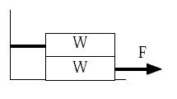

*94.Two identical blocks of weight *W* are placed one on top of the other as shown in the diagram above. The upper block is tied to the wall. The lower block is pulled to the right with a force *F*. The coefficient of static friction between all surfaces in contact is *μ*. What is the largest force *F* that can be exerted before the lower block starts to slip?

(A) μW (B) 3μW/2 (C) 2μW (D) 5μW/2 (E) 3μW

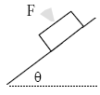

95. A force *F* is used to hold a block of mass *m* on an incline as shown in the diagram (see above). The plane makes an angle of *θ* with the horizontal and *F* is perpendicular to the plane. The coefficient of friction between the plane and the block is *μ*. What is the minimum force, *F*, necessary to keep the block at rest?

(A) μmg (B) mgcosθ (C) mgsinθ (D) mgsinθ/μ (E) mg(sinθ – μcosθ)/μ

*96.A mass *m* is resting at equilibrium suspended from a vertical spring of natural length *L* and spring constant *k* inside a box as shown.

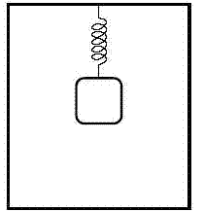

The box begins accelerating upward with acceleration *a*. How much closer does the equilibrium position of the mass move to the bottom of the box?

(A) (B) (C) (D) (E)

*97.When the speed of a rear-drive car is increasing on a horizontal road, what is the direction of the frictional force on the tires?

(A) backward on the front tires and forward on the rear tires.   
(B) forward on the front tires and backward on the rear tires.   
(C) forward on all tires.   
(D) backward on all tires.   
(E) zero.

*98.A ball of mass *m* is launched into the air. Ignore air resistance, but assume that there is a wind that exerts a constant force *F*o in the –*x* direction. In terms of *F*o and the acceleration due to gravity *g*, at what angle above the positive *x*-axis must the ball be launched in order to come back to the point from which it was launched?

(A) tan-1(*F*0/*mg*) (B) tan-1(*mg*/*F*0) (C) sin-1(*F*0/*mg*) (D) the angle depends on the launch speed   
(E) no such angle is possible

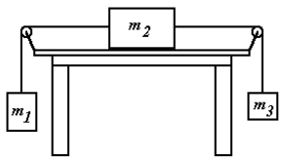

99. Given the three masses as shown in the diagram above, if the coefficient of kinetic friction between the large mass (*m*2) and the table is *μ*, what would be the upward acceleration of the small mass (*m*3)? The mass and friction of the cords and pulleys are small enough to produce a negligible effect on the system.

(A) m1g/(m1 + m2 + m3) (B) g(m1 + m2μ)/(m1 + m2 + m3) (C) gμ(m1 + m2 + m3)/ (m1 – m2 – m3)

(D) gμ(m1 – m2 – m3)/ (m1 + m2 + m3) (E) g(m1 – μm2 – m3)/ (m1 + m2 + m3)

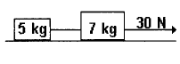

100. Two masses 5.0 and 7.0 kg are originally at rest on a frictionless surface. The masses are connected by a light cord. A second cord is attached to the 7.0 kg mass and pulled with a horizontal force of 30 N. What is the tension in the cord that connects the two masses?

(A) 5 N (B) 7 N (C) 12.5 N (D) 17.5 N (E) 30 N

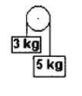

101. Two masses are connected by a light cord which is looped over a light frictionless pulley. If one mass is 3.0 kg and the second mass is 5.0 kg, what is the downward acceleration of the heavier mass? Assume air resistance is negligible.

(A) 9.8 m/s2 (B) 8.4 m/s2 (C) 6.3 m/s2 (D) 3.8 m/s2 (E) 2.5 m/s2

Questions 102 – 103

Three identical laboratory carts A, B, and C are each subject to a constant force FA, FB, and FC, respectively. One or more of these forces may be zero. The diagram below shows the position of each cart at each second of an 8.0 second interval.

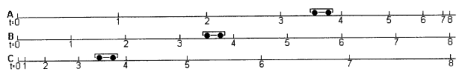

102. Which car has the greatest average velocity during the interval?

(A) A (B) B (C) C (D) all three average velocities are equal (E) not enough information is provided

103. How does the magnitude of the force acting on each car compare?

(A) FA > FB > FC (B) FA = FC > FB (C) FA > FC = FB (D) FA = FB > FC (E) not enough information provided

104. A skydiver is falling at terminal velocity before opening her parachute. After opening her parachute, she falls at a much smaller terminal velocity. How does the total upward force before she opens her parachute compare to the total upward force after she opens her parachute?

(A) The ratio of the forces is equal to the ratio of the velocities.   
(B) The ratio of the forces is equal to the inverse ratio of the velocities.   
(C) the upward force with the parachute will depend on the size of the parachute.   
(D) The upward force before the parachute will be greater because of the greater velocity.   
(E) The upward force in both cases must be the same.

105. Each of the diagrams below represents two weights connected by a massless string which passes over a massless, frictionless pulley. In which diagram will the magnitude of the acceleration be the largest?

(A) 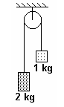(B) 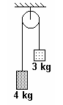 (C) 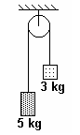 (D) 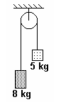 (E) 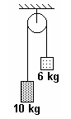

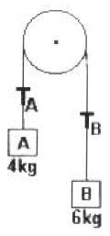

106. A simple Atwood's machine is shown in the diagram above. It is composed of a frictionless lightweight pulley with two cubes connected by a light string. If cube A has a mass of 4.0 kg and cube B has a mass of 6.0 kg, the system will move such that cube B accelerates downwards. What would be the tension in the two parts of the string between the pulley and the cubes?

(A) *T*A = 47 N ; *T*B = 71 N (B) *T*A = 47 N ; *T*B = 47 N (C) *T*A = 47 N ; *T*B = 42 N   
(D) *T*A = 39 N ; *T*B = 59 N (E) *T*A = 39 N ; *T*B = 39 N

107. If a net force *F* applied to an object of mass *m* will produce an acceleration of *a*, what is the mass of a second object which accelerates at 5*a* when acted upon by a net force of 2*F*?

(A) (2/5)*m* (B) 2*m* (C) (5/2)*m* (D) 5*m* (E) 10*m*

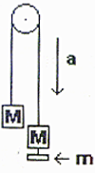

108. A simple Atwood's machine remains motionless when equal masses *M* are placed on each end of the chord. When a small mass *m* is added to one side, the masses have an acceleration *a*. What is *M*? You may neglect friction and the mass of the cord and pulley.

(A) (B) (C) (D) (E)

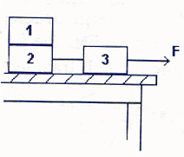

*109.Block 1 is stacked on top of block 2. Block 2 is connected by a light cord to block 3, which is pulled along a frictionless surface with a force *F* as shown in the diagram. Block 1 is accelerated at the same rate as block 2 because of the frictional forces between the two blocks. If all three blocks have the same mass *m*, what is the minimum coefficient of static friction between block 1 and block 2?

(A) 2F/mg (B) 2F/3mg (C) F/mg (D) 3F/2mg (E) F/3mg

110. An object originally traveling at a velocity, *v*0, is accelerated to a velocity, *v*, in a time, *t*, by a constant force, *F*. What would be the mass of the object?

(A) (B) (C) (D) (E)

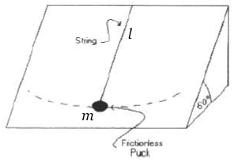

111. A frictionless air puck of mass *m* is placed on a plane surface inclined at an angle of 60° with respect to the horizontal. A string of length *l* is attached to the puck at one end and the upper edge of the inclined plane at the other to constrain the movement of the puck. What would be the magnitude of the normal force from the plane acting on the puck?

(A) *mg*(*sin* 60°) (B) *mg*(*cos* 30°) (C) *mg*(*tan* 30°) (D) (E) None of these

three blocks on horizontal surface

*112.Three blocks (*m*1, *m*2, and *m*3) are sliding at a constant velocity across a rough surface as shown in the diagram above. The coefficient of kinetic friction between each block and the surface is *μ*. What would be the force of *m*1 on *m*2?

(A) (*m*2 + *m*3)*gμ* (B) *F* – (*m*2 – *m*3)*gμ* (C) (*m*1 + *m*2 + *m*3)*gμ* (D) *F* (E) *m*1*gμ* – (*m*2 + *m*3)*gμ*

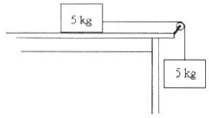

113. Two 5 kg masses are attached to opposite ends of a long massless cord which passes tautly over a massless frictionless pulley. The upper mass is initially held at rest on a table 50 cm from the pulley. The coefficient of kinetic friction between this mass and the table is 0.2. When the system is released, its resulting acceleration is closest to which of the following?

(A) 9.8 m/s2 (B) 7.8 m/s2 (C) 4.9 m/s2 (D) 3.9 m/s2 (E) 1.9 m/s2

SECTION B – Circular Motion

1. When a person stands on a rotating merry‑go‑round, the frictional force exerted on the person by the merry‑go‑round is

(A) greater in magnitude than the frictional force exerted on the person by the merry‑go‑round

(B) opposite in direction to the frictional force exerted on the merry‑go‑round by the person

(C) directed away from the center of the merry‑go‑round

(D) zero if the rate of rotation is constant

(E) independent of the person's mass

2. A ball attached to a string is whirled around in a horizontal circle having a radius r. If the radius of the circle is changed to 4r and the same centripetal force is applied by the string, the new speed of the ball is which of the following?  
(A) One‑quarter the original speed (B) One‑half the original speed   
(C) The same as the original speed (D) Twice the original speed  
(E) Four times the original speed

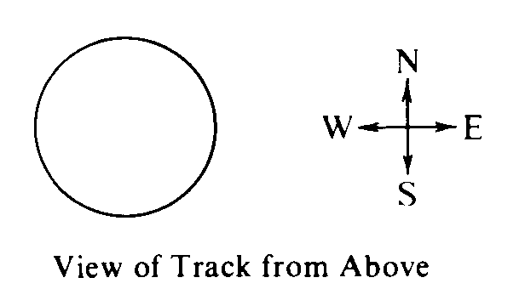

3. A racing car is moving around the circular track of radius 300 meters shown above. At the in­stant when the car's velocity is directed due east, its acceleration is directed due south and has a magnitude of 3 meters per second squared. When viewed from above, the car is moving

(A) clockwise at 30 m/s ( B) clockwise at 10 m/s (C) counterclockwise at 30 m/s

(D) counterclockwise at 10 m/s (E) with constant velocity

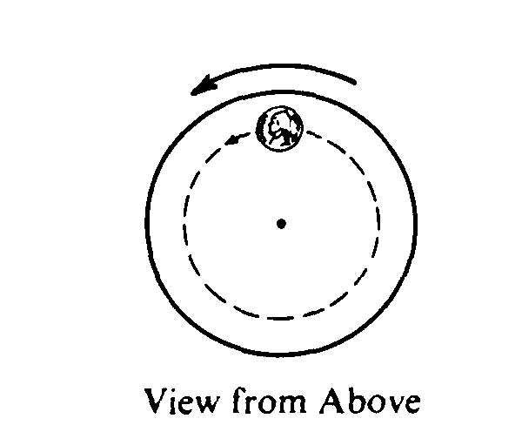

4. The horizontal turntable shown above rotates at a constant rate. As viewed from above, a coin on the turntable moves counterclockwise in a circle as shown. Which of the following vectors best represents the direction of the frictional force exerted on the coin by the turntable when the coin is in the position shown?  
(A)  (B)  (C)  (D)  (E) 

5. In which of the following situations would an object be accelerated?  
I. It moves in a straight line at constant speed.  
II. It moves with uniform circular motion.  
III. It travels as a projectile in a gravitational field with negligible air resistance.  
(A) I only (B) III only (C) I and II only (D) II and III only (E) I, II, and III.

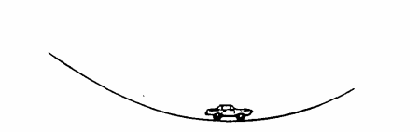

6. An automobile moves at constant speed down one hill and up another hill along the smoothly curved surface shown above. Which of the following diagrams best represents the directions of the velocity and the acceleration of the automobile at the instant that it is at the lowest position. as shown?  
(A)  (B)  (C)  (D)  (E) 

7. A car initially travels north and then turns to the left along a circular curve. This causes a package on the seat of the car to slide toward the right side of the car. Which of the following is true of the net force on the package while it is sliding?  
(A) The force is directed away from the center of the circle.  
(B) The force is directed north.  
(C) There is not enough force directed north to keep the package from sliding.  
(D) There is not enough force tangential to the car's path to keep the package from sliding.  
(E) There is not enough force directed toward the center of the circle to keep the package from sliding.

8. A child has a toy tied to the end of a string and whirls the toy at constant speed in a horizontal circular path of radius *R*. The toy completes each revolution of its motion in a time period *T*. What is the magnitude of the acceleration of the toy?

(A) Zero (B)  (C)  (D) *g* (E) *2πg*

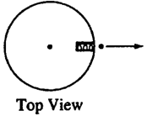

9. A compressed spring mounted on a disk can project a small ball. When the disk is not rotating, as shown in the top view above, the ball moves radially outward. The disk then rotates in a counterclockwise direction as seen from above, and the ball is projected outward at the instant the disk is in the position shown above. Which of the following best shows the subsequent path of the ball relative to the ground?

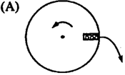 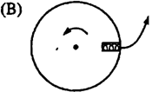 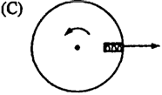 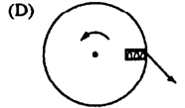 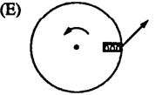

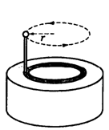

10. A steel ball supported by a stick rotates in a circle of radius *r*, as shown above. The direction of the net force acting on the ball when it is in the position shown is indicated by which of the following?

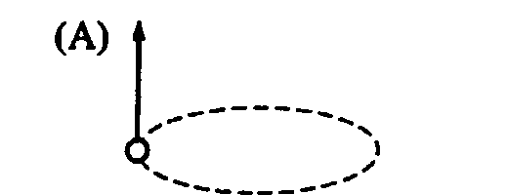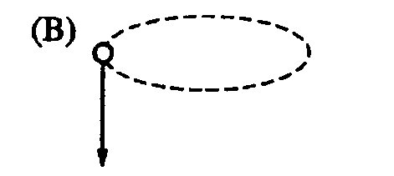 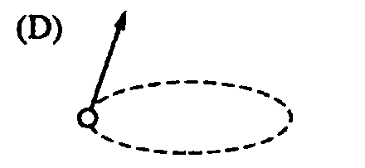

11. Inside a washing machine, the radius of the cylinder where the clothes sit is 0.50 m. In one of its settings the machine spins the cylinder at 2.0 revolutions per second. What is the acceleration of an item of clothing?

(A) 0.080 m/s2 (B) 1.6 m/s2 (C) 8.0 m/s2 (D) 79 m/s2 (E) 25 m/s2

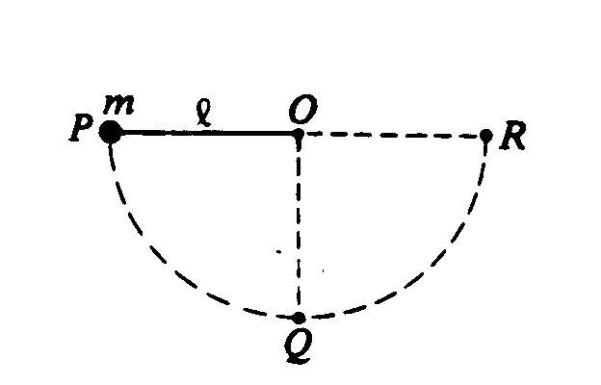

12. A ball of mass m is attached to the end of a string of length Q as shown above. The ball is released from rest from position P. where the string is hori­zontal. It swings through position Q. where the string is vertical, and then to position R. where the string is again horizontal. What are the directions of the acceleration vectors of the ball at positions Q and R?

Position Q Position R

(A) Downward Downward

(B) Downward To the right

(C) Upward Downward

(D) Upward To the left

(E) To the right To the left

13. A mass m moves on a curved path from point X to point Y. Which of the following diagrams indicates a possible combination of the net force F on the mass, and the velocity v and acceleration a of the mass at the loca­tion shown?

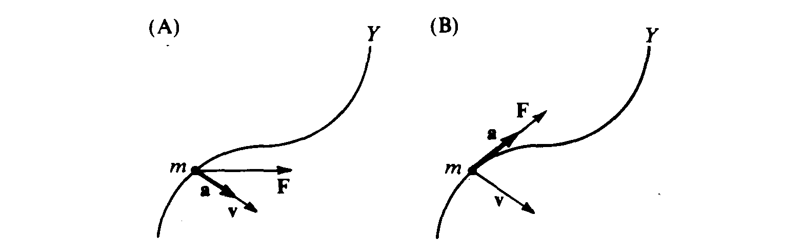 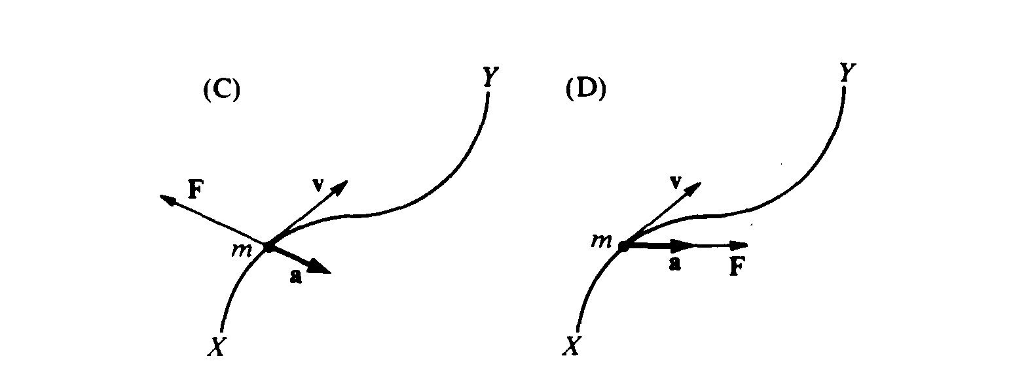 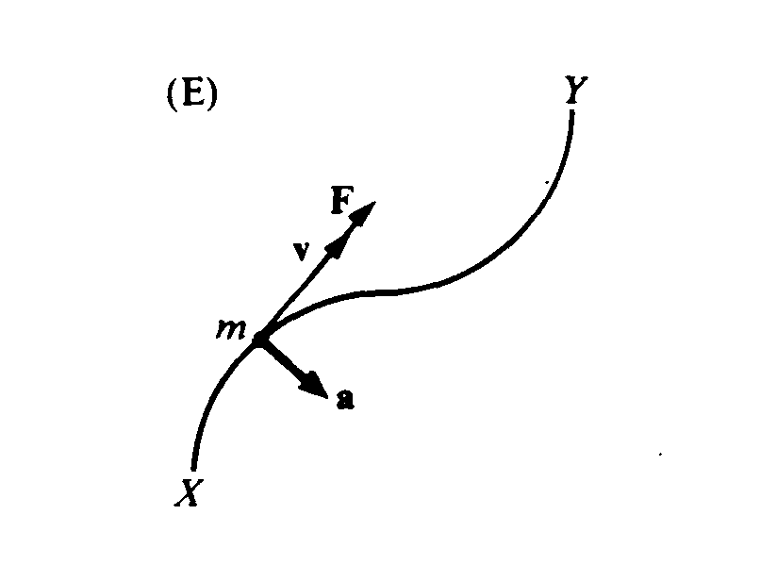

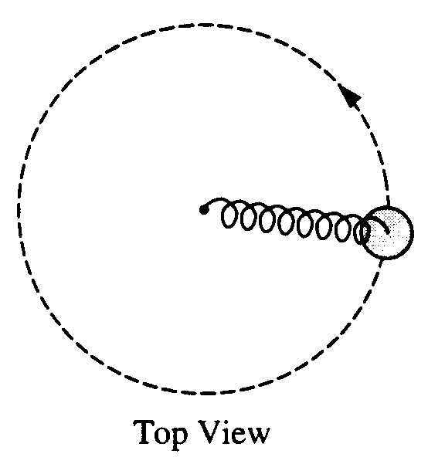

*14. A spring has a force constant of 100 N/m and an unstretched length of 0.07 m. One end is attached to a post that is free to rotate in the center of a smooth table, as shown in the top view above. The other end is attached to a 1 kg disc moving in uniform circular motion on the table, which stretches the spring by 0.03 m. Friction is negligible. What is the centripetal force on the disc?   
(A) 0.3 N (B) 3N (C) 10 N (D) 300 N (E) 1,000 N

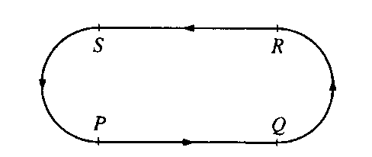

15. A figure of a dancer on a music box moves coun­terclockwise at constant speed around the path shown above. The path is such that the lengths of its segments, *PQ, QR, RS*, and *SP*, are equal. Arcs *QR* and *SP* are semicircles. Which of the following best represents the magnitude of the dancer's acceleration as a function of time t during one trip around the path, beginning at point *P* ?

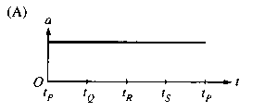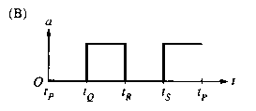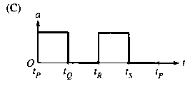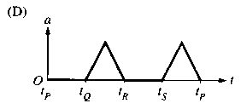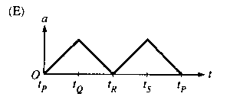

16. A car travels forward with constant velocity. It goes over a small stone, which gets stuck in the groove of a tire. The initial acceleration of the stone, as it leaves the surface of the road, is

(A) vertically upward (B) horizontally forward (C) horizontally backward

(D) zero (E) upward and forward, at approximately 45° tothe horizontal



17. A car is traveling on a road in hilly terrain, see figure to the right. Assume the car has speed *v* and the tops and bottoms of the hills have radius of curvature *R*. The driver of the car is most likely to feel weightless:

(A) at the top of a hill when  (B) at the bottom of a hill when

(C) going down a hill when (D) at the top of a hill when    
(E) at the bottom of a hill when



18. An object shown in the accompanying figure moves in uniform circular motion. Which arrow best depicts the net force acting on the object at the instant shown?

(A) A (B) B (C) C (D) D (E) E

19. A child whirls a ball at the end of a rope, in a uniform circular motion. Which of the following statements is **NOT** true?

(A) The speed of the ball is constant (B) The velocity is of the ball is constant (C) The radius is constant

(D) The magnitude of the ball's acceleration is constant  
(E) The acceleration of the ball is directed radially inwards towards the center

20. An astronaut in an orbiting space craft attaches a mass *m* to a string and whirls it around in uniform circular motion. The radius of the circle is *r*, the speed of the mass is *v*, and the tension in the string is *F*. If the mass, radius, and speed were all to double the tension required to maintain uniform circular motion would be

(A) *F*/2 (B) *F* (C) 2*F* (D) 4*F* (E) 8*F*

21. Assume the roller coaster cart rolls frictionlessly along the curved track from point A to point C under the influence of gravity. What would be the direction of the cart's acceleration at point B?

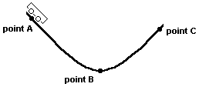

(A) upward  
(B) downward  
(C) forward  
(D) backward  
(E) no acceleration

Questions 22 – 23

The diagram below is a snapshot of three cars all moving counterclockwise during a one lap race on an elliptical track.

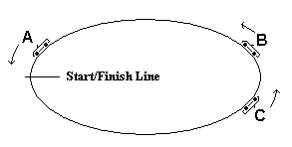

22. Which car has had the lowest average speed during the race so far?

(A) car A (D) all three cars have had the same average speed

(B) car B (E) cannot be determined with information provided

(C) car C

23. Which car at the moment of the snapshot MUST have a net force acting on it?

(A) car A (D) all three cars have net forces acting on them

(B) car B (E) cannot be determined with information provided

(C) car C

24. A centripetal force of 5.0 newtons is applied to a rubber stopper moving at a constant speed in a horizontal circle. If the same force is applied, but the radius is made smaller, what happens to the speed, *v*, and the frequency, *f*, of the stopper?

(A) *v* increases & *f* increases (D) *v* decreases & *f*  increases

(B) *v* decreases & *f* decreases (E) neither changes

(C) *v* increases & *f* decreases

1. 25. What is the centripetal acceleration of an object (mass = 50 g) on the end of an 80-cm string rotating at a constant rate of 4 times a second?
   1. (A) 25 m/s2 (B) 32 m/s2 (C) 100 m/s2 (D) 500 m/s2 (E) 2500 m/s2

26. What net force is necessary to keep a 1.0 kg puck moving in a circle of radius 0.5 m on a horizontal frictionless surface with a speed of 2.0 m/s?

(A) 0 N (B) 2.0 N (C) 4.0 N (D) 8.0 N (E) 16 N



27. Astronauts on the Moon perform an experiment with a simple pendulum that is released from the horizontal position at rest. At the moment shown in the diagram with 0° <θ < 90°, the total acceleration of the mass may be directed in which of the following ways?

(A) straight to the right (B) straight to the left (C) straight upward (D) straight downward

(E) straight along the connecting string toward point P (the pivot)

28. A 4.0 kg mass is attached to one end of a rope 2 m long. If the mass is swung in a vertical circle from the free end of the rope, what is the tension in the rope when the mass is at its highest point if it is moving with a speed of 5 m/s?

(A) 5.4 N (B) 10.8 N (C) 21.6 N (D) 50 N (E) 65.4 N

29. A ball of mass *m* is fastened to a string. The ball swings at constant speed in a vertical circle of radius *R* with the other end of the string held fixed. Neglecting air resistance, what is the difference between the string's tension at the bottom of the circle and at the top of the circle?

(A) 1·*mg* (B) 2·*mg* (C) 4·*mg* (D) 6·*mg* (E) 8·*mg*

30. An object weighing 4 newtons swings on the end of a string as a simple pendulum. At the bottom of the swing, the tension in the string is 6 newtons. What is the magnitude of the centripetal acceleration of the object at the bottom of the swing?   
(A) 0 (B) 0.5 g (C) g (D) 1.5 g (E) 2.5 g

31. Riders in a carnival ride stand with their backs against the wall of a circular room of diameter 8.0 m. The room is spinning horizontally about an axis through its center at a rate of 45 rev/min when the floor drops so that it no longer provides any support for the riders. What is the minimum coefficient of static friction between the wall and the rider required so that the rider does not slide down the wall?

(A) 0.0012 (B) 0.056 (C) 0.11 (D) 0.53 (E) 8.9